Forked Deer Cumberland Presbyterian Women’s Ministry

Dear Sister in Christ,

It’s time for our Spring Retreat, and we hope that you will be able to join us at Camp Clark Williamson on Saturday, March 11, 2023.
Please distribute this information to the ladies in your church and encourage them to attend. I am enclosing a registration form.
Send your completed forms to Alison Coleman, 247 Auburn Avenue, Dyersburg, Tennessee 38024 no later than February 28, 2023. Please make your checks payable to Forked Deer CPW. Do not contact Mike Hannaford of Camp Clark Williamson directly for reservations.
At the end of the meeting, regional groups will be given an opportunity to meet. If you have any questions, please contact me at 731-676-8626 or jamiekayb@hotmail.com.

We look forward to seeing you!

Jamie Kay Berkley
Forked Deer Regional Secretary
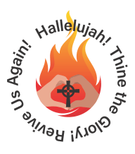

When: March 11, 2023
Registration 9:30 – 10:00 a.m.
Meeting begins at 10:00 a.m.

Where: Camp Clark Williamson

