Responsive Reading based on Leviticus 23:22 (ESV)
By Rev. Kristi Lounsbury

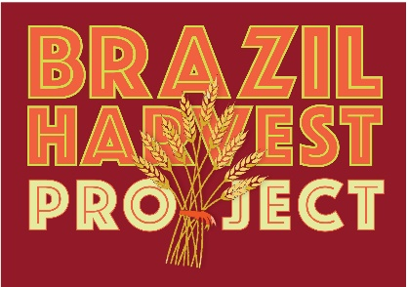

Leader: God has said, “I am the Lord your God.”
People: We want to worship and honor you, O God.
Leader: God has said, “Plant a plentiful harvest, but don’t take it all.”
People: We will reap only what you tell us to reap.
Leader: God has said, “Leave the edges of the fields alone.”
People: We will reserve the fringes of the sowed for others.
Leader: God has said, “Gather only the stalks.”
People: We will leave the grains for gleaning.
Leader: God has said, “Take care of the poor and the sojourner.”
People: We will be in relationship with one another.
ALL: For you are the Lord our God.

