FINANCIAL REPORT
LOAVES & FISHES OFFERING

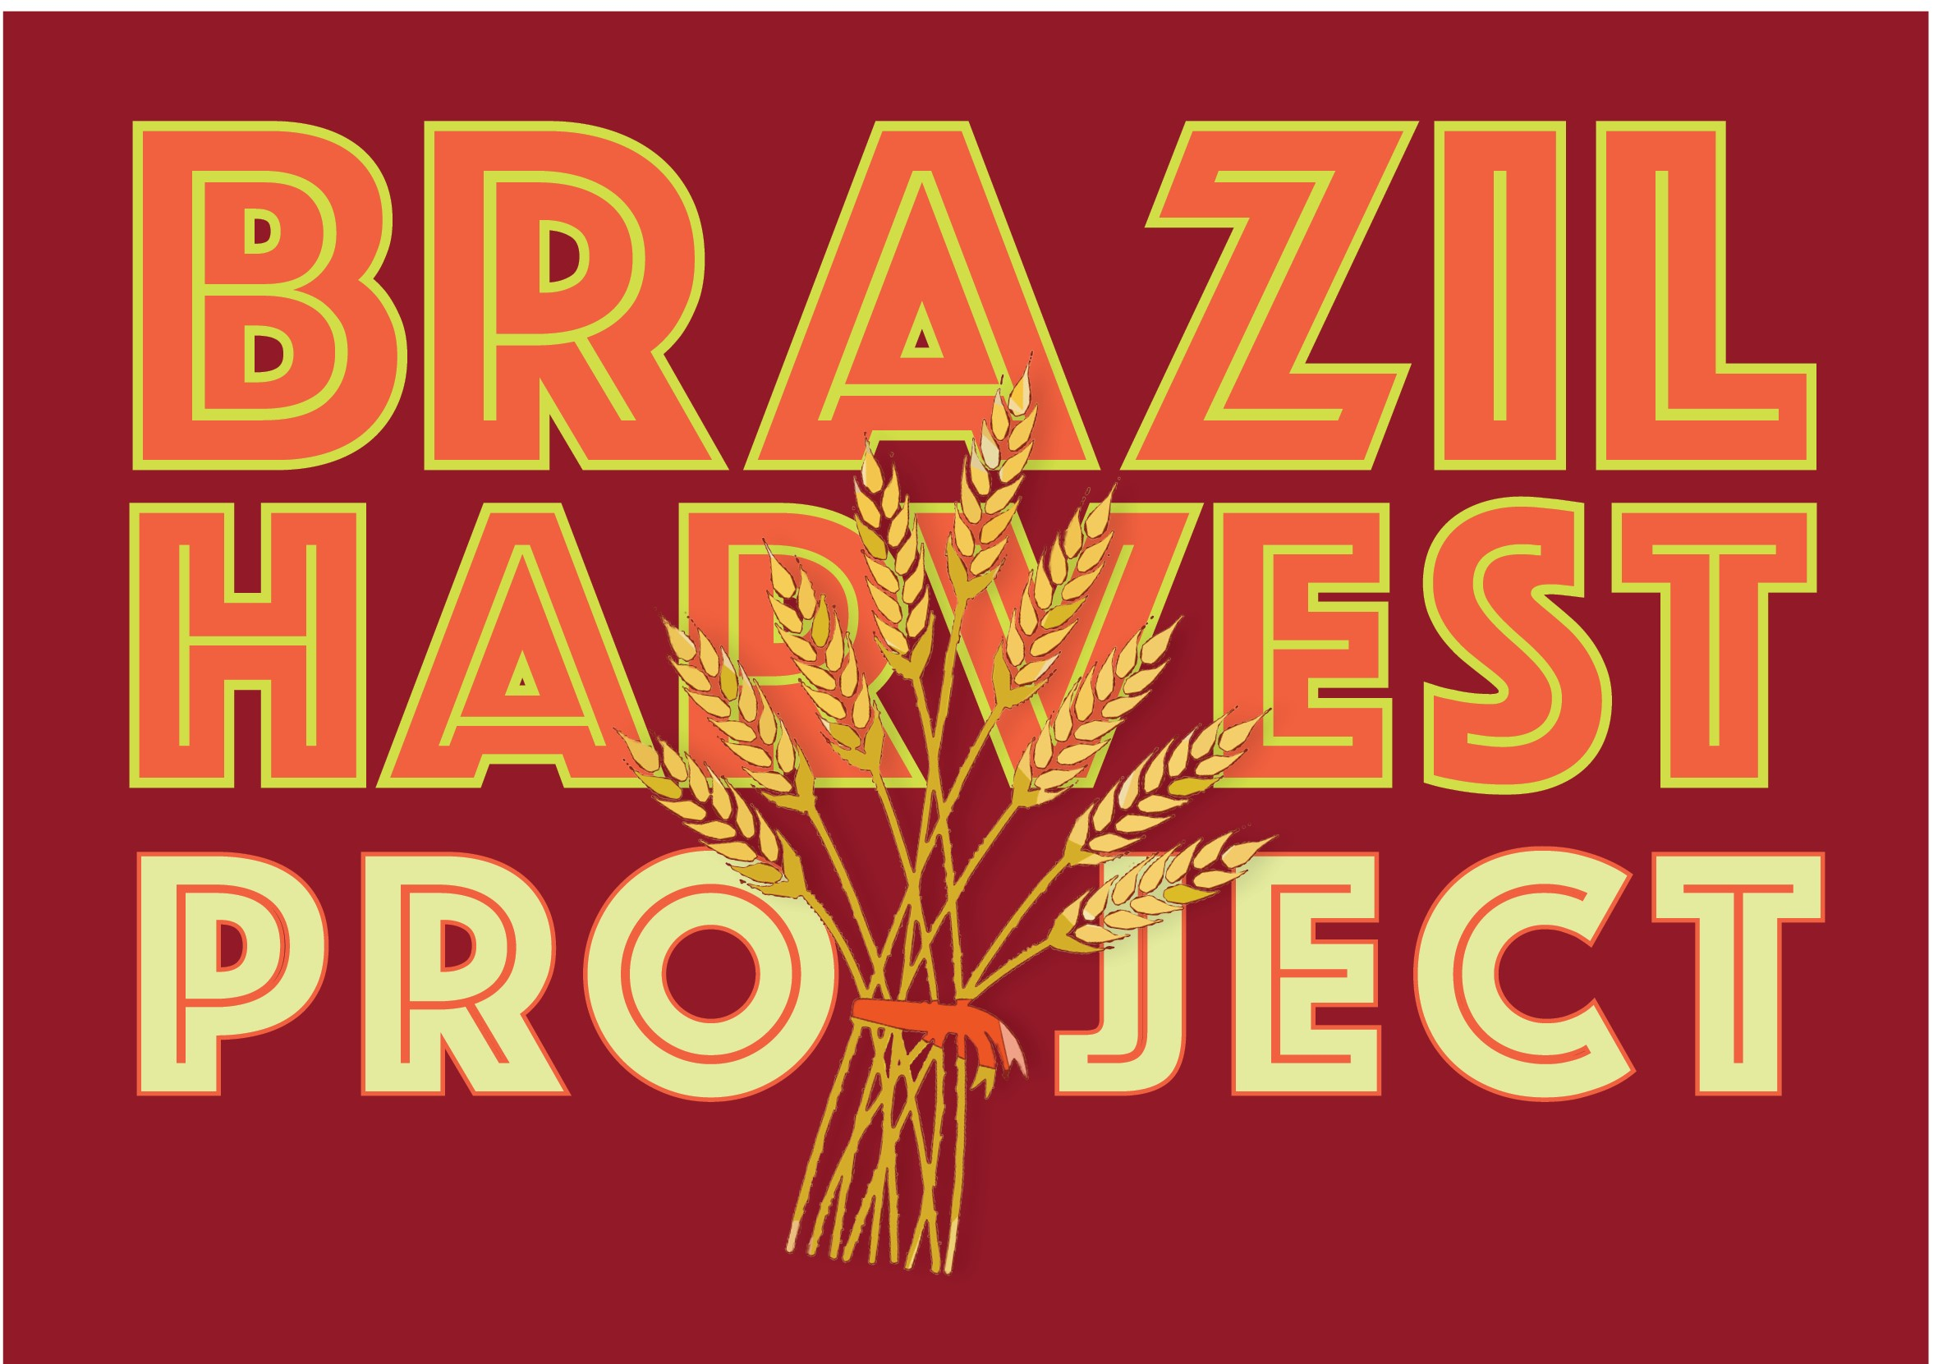

(Return one copy, along with your offering, to the Missions Ministry Team by
December 31, 2022; retain one copy for your files.)

CHURCH INFORMATION

Church Name_____________________________________________________

Address__________________________________________________________
Street City State Zip

PLEASE NOTE: Participation in the Loaves & Fishes Program is a commitment of the congregation or church group to distribute the proceeds as follows:

75% to Brazil Harvest Project; 25% for local hunger programs.

If there are no local hunger concerns, the balance of the offering may be forwarded to the Missions Ministry Team.

FINANCIAL REPORT

Make checks payable to the Missions Ministry Team.

1. Total Loaves & Fishes Offering received: $______________________________________

2. Amount retained (up to 25%) for local hunger programs: $____________________________

3. We have enclosed a check (75%) in the amount of $________________________________

* * * * * * * * * * * * * * * * * * * * * * * * * * * *

On behalf of those who will be helped because of your loving concern, we express our gratitude for sharing in this ministry. It is our hope that this program challenged your congregation by making it more aware of the world’s needs.

