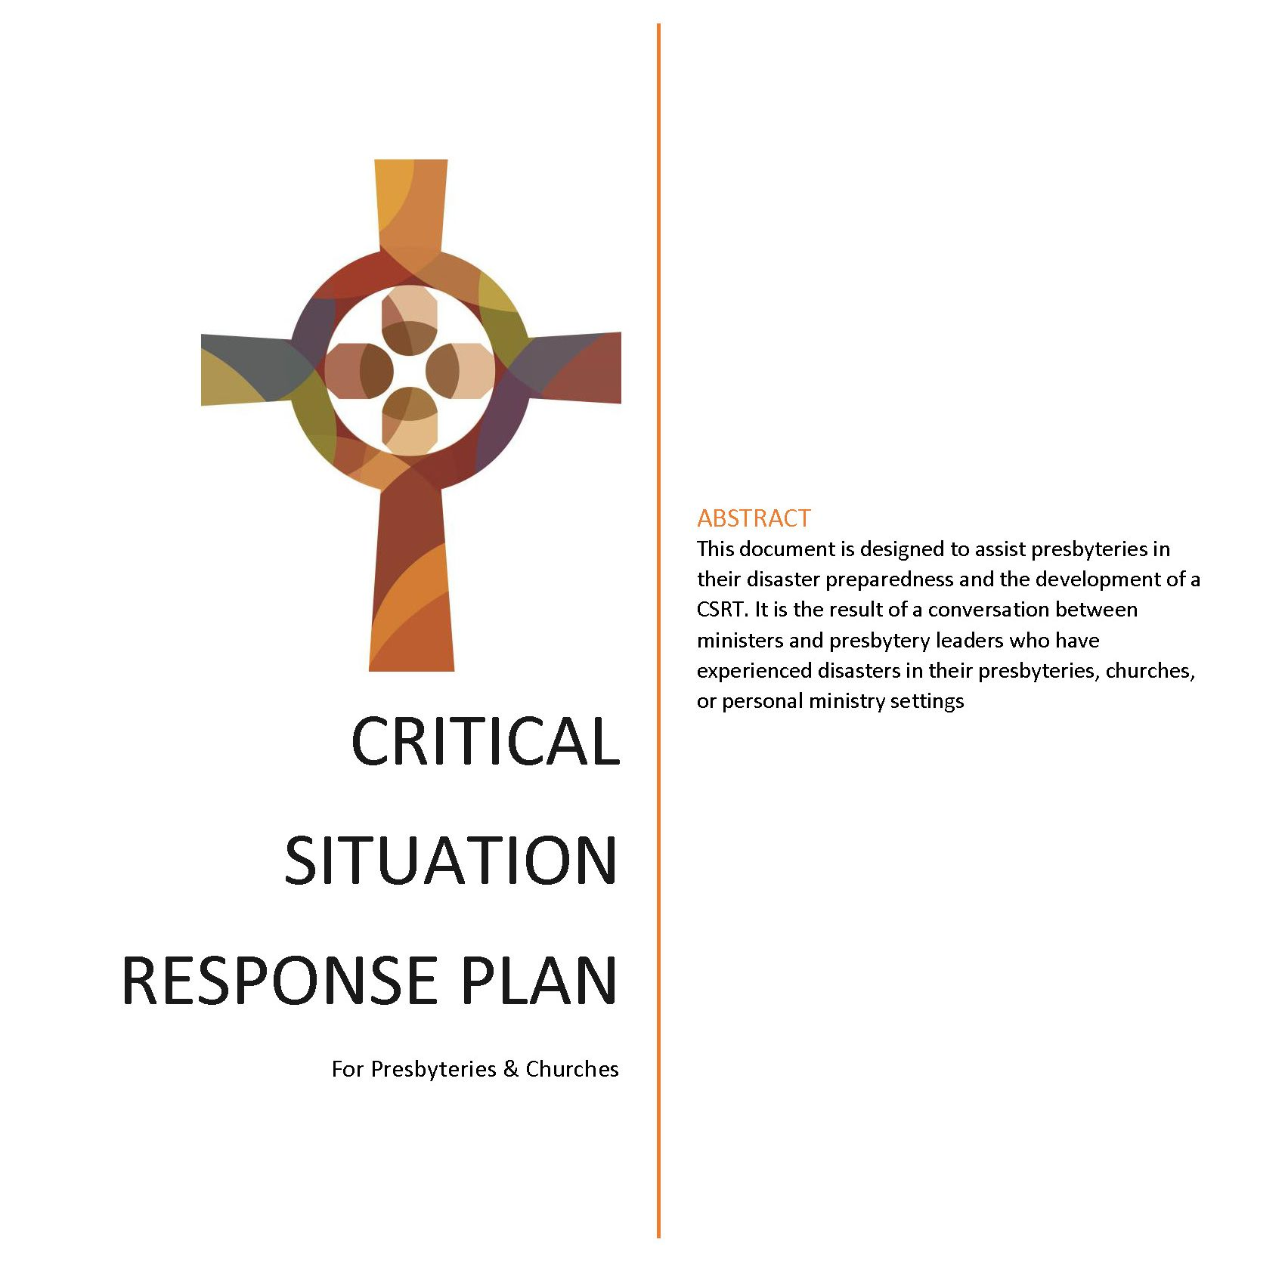
BEST PRACTICES for a
Critical Situation Response Team
Introduction
A disaster is a serious occurrence that can be short- or long-term in duration causing significant disruptions in a community that exceeds its ability to cope using its own resources. Disasters can be natural or man-made. Examples of disasters include destruction caused by tornadoes, floods, hurricanes, fires or violence. The 190th General Assembly instructed each presbytery to create a Crisis Situation Response Team (CSRT) to function in the event of a disaster within the bounds of their presbytery.
This document is designed to assist presbyteries in their disaster preparedness and the development of a CSRT. It is the result of a conversation between ministers and presbytery leaders who have experienced disasters in their presbyteries, churches, or personal ministry settings. The following ministers offered their insights and recommendations: Rev. Donny Acton (Grace Presbytery), Rev. Leslie Johnson (Red River Presbytery), Elder Lora Kerner (Covenant Presbytery), Rev. Tyler Lindsey (Cumberland Presbytery), Elder Ollie McClung (Grace Presbytery), Rev. Jeff McMichael (Cumberland Presbytery), Rev. Sheila O’Mara (del Cristo Presbytery, PDMT Elected Member), Rev. Christian Smith (Murfreesboro Presbytery), and Rev. Pam Phillips-Burk (Pastoral Development Ministry Team Leader).
This resource will highlight “Best Practices” when creating a Critical Situation Response plan. Each presbytery is encouraged to develop a plan unique to your own setting and needs. For presbyteries that span multiple counties, cities or even states, it may be necessary to have multiple plans in place. The Critical Situation Response Team will not necessarily meet regularly but be activated in the event of a disaster. The plan will need to be reviewed annually by the CSRT and included in the preliminary minutes so that the churches in the presbytery will have a copy of it for their use in the event of a disaster.
Times of disaster bring uncertainty and fear. Being prepared can help alleviate anxiety and uncertainly. In addition, God’s word is a source of comfort and strength when disasters occur. The Psalmist remind us that “God is our refuge and strength, an ever-present help in troubles. Therefore, we will not fear, though the earth give way and the mountains fall into the heart of the sea.” (Psalm 46:1-2)
This manual is designed for presbyteries/churches to add to it as plans develop. An electronic Word document can be downloaded at: https://cpcmc.org/wp-content/uploads/2022/08/CSRT-Best-Practices.docx
BEFORE a Disaster
- Create a Critical Situation Response Team
  - Board of Missions Chairperson or representative
  - Committee on Ministry/Clergy Care Chairperson or representative
  - Presbytery Clerk
  - Presbytery Treasurer
  - Presbytery Moderator
  - Member-at-Large
  - Member-at-Large
A chairperson will be needed for this team. The chairperson will activate the team in the event of an emergency via a phone call or text. This team does not need to meet unless there is a disaster/crisis within the bounds of the presbytery.
Determine how the members-at-large will rotate off and new members rotate on.
The plan will need to be reviewed annually and included in the preliminary minutes of presbytery.
- Create a directory of local/regional support organizations/agencies. You will need names and contact information.
  - EMS Director
  - Police Chief/Representative
  - FEMA
  - Red Cross
  - Salvation Army
  - Mental Healthcare Providers
  - There is typically a local group (often times consisting of those agencies/people listed above) that is quickly established in the event of a disaster. Know what the community plan is and communicate that plan to the churches in your presbytery.

- Finances/Donations/Record-keeping
  - Set up a presbyterial Disaster Relief line item/or separate account.
  - All donations will need to be acknowledged and correctly receipted.
  - If donations go through the denominational Missions Ministry Team (MMT), it will be acknowledged and receipted; then those funds will be forwarded on to the designated presbytery entity. (There is an MMT Disaster Relief Fund Protocol provided at the end of this document)
  - Determine how and when donated funds will be dispersed. Donations will need to be dispersed in a timely manner.
  - Report to presbytery the amount of donations received and dispersed
  - This team should recommend that churches review their insurance coverage to ensure there is adequate coverage. The time to discover that insurance is not sufficient is BEFORE a disaster and not AFTER.
  - Keep a record of volunteers/donations – for vetting purposes and to give thanks.
  - It’s important to document the crisis – who helped, who donated, the stories that were told. Storytelling will be important in recovery; it will also help continue to build up the resource list of people who have experience.

- Trauma and Mental Health Issues following a disaster
  - Know your resources for mental health care BEFORE a disaster happens.
  - Name and Contact information of area mental health practices. Maybe there is a trained social worker or counselor in your presbytery who can offer guidance. It’s important to know these resources ahead of time. Include names and contact information in this document.
- Security
  - Consider taking training regarding security issues during a disaster – site security, donations, scammers, etc. Check with your local resource agencies. Attention beforehand to this issue will make you better prepared for a disaster in the future.

DURING a Disaster
- Receive, acknowledge, and receipt all donations. It is important that churches in the presbytery know where to send any donations, if they do not go through the denomination MMT. Remember, all donations that go through the MMT will be receipted and acknowledged. The MMT will then forwarded ALL donations to the appointed presbyterial recipient.
- Site Security will be important during a disaster. Often area emergency agencies will provide security boundaries. If not, then this team will want to consider those issues.
- Scammers - Put in place ahead of time a method of vetting folks who come seeking support to deal with scammers who will try to take advantage of donations and resources. Check with local emergency agencies on security protocol or vetting people who come for help.
- Communicate with affected churches/ministers right away. THEN communicate with churches in the presbytery regarding needs, plans, and ways to support.
- Ministers in affected churches need support right away.
  - Volunteers may be needed at affected churches to answer phones and support the pastor.
  - To support a minister, find someone to fill the pulpit (if needed) for a few Sundays while the pastor deals with the crisis in the church/area/life.
  - Appoint someone to be the support person for the pastor.
  - Provide information about the denominational Employee Assistance Program (EAP) and other mental health resources for the pastor/pastor’s family.
- Churches that have been affected by a disaster may need volunteers outside their membership to deal with donations, phone calls, etc.
  - Check with the church to see how others in the presbytery can offer support. THEN communicate that need out to the churches. Members from other churches can bring HOPE to the situation.
  - Appoint a person to organize the volunteers and donations; to “vet” the volunteers; etc.
- Prayer support will be needed during and after a disaster. Determine how this team or presbytery will be intentional in offering this important support and resources.

AFTER a Disaster
- Continue to check in with the pastor regarding mental health, finances, spiritual life. Remind them of the EAP resources.
- Trauma-focused support - trauma often does not surface until after a disaster.
  - Be prepared to offer resources to pastors or church members. Consider a church-wide or presbytery-wide debrief giving special attention to trauma and mental health.
  - Don’t forget that children and teens are affected by disasters just like adults, so make sure you provide mental health support for that group as well.
- A Debrief and Defuse session might be needed a few weeks after the immediate crisis. Consider contacting keys folks who have gone through a disaster (a directory/contact list will be included at the end of this document). Training might be needed for key leaders to recognize trauma in their members or self. Look for support from local agencies, the denomination, or a national organization.
- Work Teams – The CSRT will want to monitor ongoing needs/work well past the initial clean up and restoration. Make sure there is a point of contact for any work teams coming in from outside the area. This might be the chairperson of the CSRT, the local pastor, or other person. Work with the denomination’s Missions Ministry Team (Director of Congregational Ministries, Rev. Kristi Lounsbury, klounsbury@cumberland.org, 901/276-4572, x263.)
Denominational Resource
- Members of this CSRT discussion group who have direct disaster crisis experience
  - Donny Acton – donnyacton@gmail.com
  - Pat Driskell – patprespax@yahoo.com
  - Leslie Johnson – pastorlesliej@gmail.com
  - Lora Rogers Kerner – lkerner@bellsouth.net
  - Tyler Lindsey – atlindsey@memphisseminary.edu
  - Nate Mathews – revnatemathews@gmail.com
  - Ollie McClung – olliewjr@bellsouth.net
  - Jeff McMichael – revmcmichael@outlook.com
  - Shelia O’Mara – chaplainshelia@aol.com
  - Christian Smith – christian@cookevillecpchurch.org
- Kristi Lounsbury – Congregational Ministries of the Missions Ministry Team (klounsbury@cumberland.org; 901/276-4572, x263)
- Pam Phillips-Burk – Pastoral Development Ministry Team Leader (pam@cumberland.org; 901/276-4572, x203)
- Matt Gore – Interim Communications Ministry Team Leader (mgore@cumberland.org; 901/276-4572, x221)
- MMT Disaster Relief Fund Protocol (found at the end of this document)

Training Opportunities
- Consider periodic training for CSRT and other leaders in the presbytery on disaster response and recovery; dealing with compassion fatigue and PTSD (what it is, symptoms, how to respond, etc.)
- Check with denominational resources on any new or ongoing training

Needed Resources
Each disaster is unique (tornado, hurricane, shooting, fire, etc.) and will require unique resources. The most common natural disasters might need some of the following items immediately:
- Generator
- Shop Vac
- Muck buckets – filled with cleaning supplies like rubber gloves, bleach, etc.
- Trailers
- Chainsaws
- Shovels, brooms,
- Spiritual support on-sight right away
- Volunteers to unload truckloads of supplies and to help sort/organize

This resource is offered as a guide to get a presbytery started in their disaster preparedness. You may not be able to do everything in this document right away. Pick out the most important ones to start with and add additional components slowly. God’s presence is vividly present when kindness, support and love are offered when there is hurt and pain. Churches are able to offer much-needed support during a crisis. The better prepared your presbytery is, the more of service you will be. Know your limits as a church/presbytery; be open to opportunities to serve but avoid trying to do it all.

“Have I not commanded you? Be strong and courageous. Do not be afraid; do not be discouraged, for the Lord your God will be with you wherever you go.” Joshua 1:9

Disaster Response Protocol
When a disaster occurs in the US, the Director of Congregational Ministries (DCM) assists the Communications Ministry Team (CMT) to gather information, coordinates volunteers, and helps to steer disaster funding in the right direction to churches and individuals. When disaster strikes, there can be confusion as to what response/responsibility/role is played by the Ministry Council. Often when news begins to spread of a disaster, phone calls, emails, and/or texts pour in from Cumberland Presbyterians wanting to know details and wanting to help. Missions Ministry Team asks church leaders to share the following guidelines to help local groups and individuals to provide appropriate disaster response.
Disasters inside the US: Immediate Contact is Kristi Lounsbury, 901-276-4572, Ext 263, cell 940-435-5077, klounsbury@cumberland.org.
Disasters outside the US: Immediate Contact is Lynn Thomas, 901-276-4572, Ext 261, cell 205-601-5770, lynndont@gmail.com.

- When a Ministry Council (MC) staff member learns of a disaster, s/he notifies the appropriate immediate contact by phone call, text, or email.
- Then the Director of Congregational Ministries or the Director of Global Missions will text the MMT Leader, Director of Ministries, and the Interim CMT Leader.
- The Director of Congregational Ministries or the Director of Global Missions and Interim CMT Leader will coordinate an initial public announcement reflecting what was known at that time.
- The public announcement will be broadcast in the following order to keep the denomination informed.
a. Church at large
b. Posted on the MC website cpcmc.org
c. Posted on social media
d. Staff will share via their respective social media pages
e. Updates sent to the CMT
f. Updates posted to social media pages in a timely manner
- Disasters in the US: if a MC member becomes aware of CP leadership arising during the disaster (pastor, member, etc.), they will notify the Director of Congregational Ministries so that an attempt to coordinate efforts can be established. The Director will then contact the aforementioned person(s) to work together to establish a cohesive response to the disaster.

