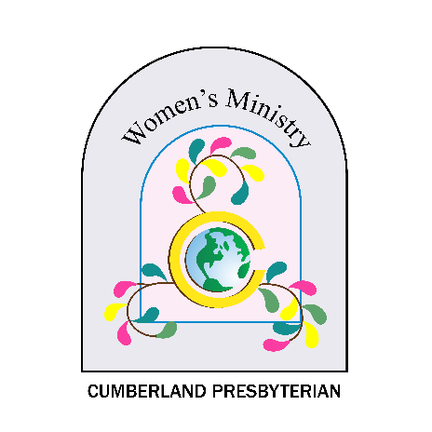
2022-2023
Women’s Ministry Projects & Offerings
Stott-Wallace Missionary Fund
Convention voted for all local and regional women’s ministry groups to collectively support the Stott-Wallace Missionary Fund at the FALL of each year. This fund goes to support the salaries and benefits of CP missionaries serving outside the United States. Women of the Cumberland Presbyterian Church have deep roots in supporting missionaries and the missionary effort. This collective project will once again unite women in supporting CP missionaries.
Funding Goal: Not Specified
Make checks payable to Missions Ministry Team (8207 Traditional Place, Cordova, TN 38016) and designate for “CPWM Stott-Wallace Offering” - #34026).

After-School Enrichment & Youth Development-Project Vida

Gangs and juvenile delinquency historically have had a strong presence in south-central El Paso, where there are few to no out-of-school-time programs other than Project Vida’s. Children and youth face risk factors including the far-reaching effects of intergenerational poverty, poor English skills, lack of academic support, and other conditions often leading to gang involvement, underage drinking, substance abuse, truancy, bullying, and premature sexual activity. Inadequate supportive, educational, enriching out-of-school-time programs exacerbate these risks. Project Vida proposes to offer age-appropriate STEAM (Science, Technology, Engineering, Art, Mathematics), character development, and creative enrichment programs and projects for school-age children and youth 6-18 years in its After-School Enrichment & Youth Development program: academic support, tutoring, reading programs, arts & crafts, fine arts projects and exhibitions, educational field trips, recreation, community service learning with family involvement, life choice skills evidence-based curriculum, college readiness programs for middle and high school participants and parents, and a vital emphasis on STEAM and tech-based instruction and activities through Project Vida’s Best Buy Teen Tech Center for all participants.

Funding Goal: Not Specified
Make checks payable to Missions Ministry Team (8207 Traditional Place, Cordova, TN 38016) and designate for “Project Vida After School” - #34027).

Food Rescue Van for Beth-EL Mission Food Pantry-Beth-El Farmworker Ministry

Beth-El’s Mission is “Feeding the Mind, Spirit, and Body of the farm working community and our neighbors in need, through opportunities for hunger relief, education, healthcare, and spiritual growth.” Their Food Pantry support team and volunteers drive over 6,000 miles every year picking up donations from our retail partners such as Walmart, Publix, and Winn-Dixie, 3 times a week. These food rescue programs are the food pantry’s main source of dairy, meat, and fresh produce to be distributed to families suffering from food insecurity. Currently, their fleet is comprised of one cargo van and a passenger van, both are 6 cylinders. Due to the limited amount of cargo they can pull they are unable to pick as many donations as there are available. Your help will go towards purchasing an 8-cylinder cargo van that can pull more weight with a bigger trailer (donated in 2020) to its full capacity.
Funding Goal: Not Specified

Make checks payable to Missions Ministry Team (8207 Traditional Place, Cordova, TN 38016) and designate for “Beth-El Cargo Van” - #34051).

