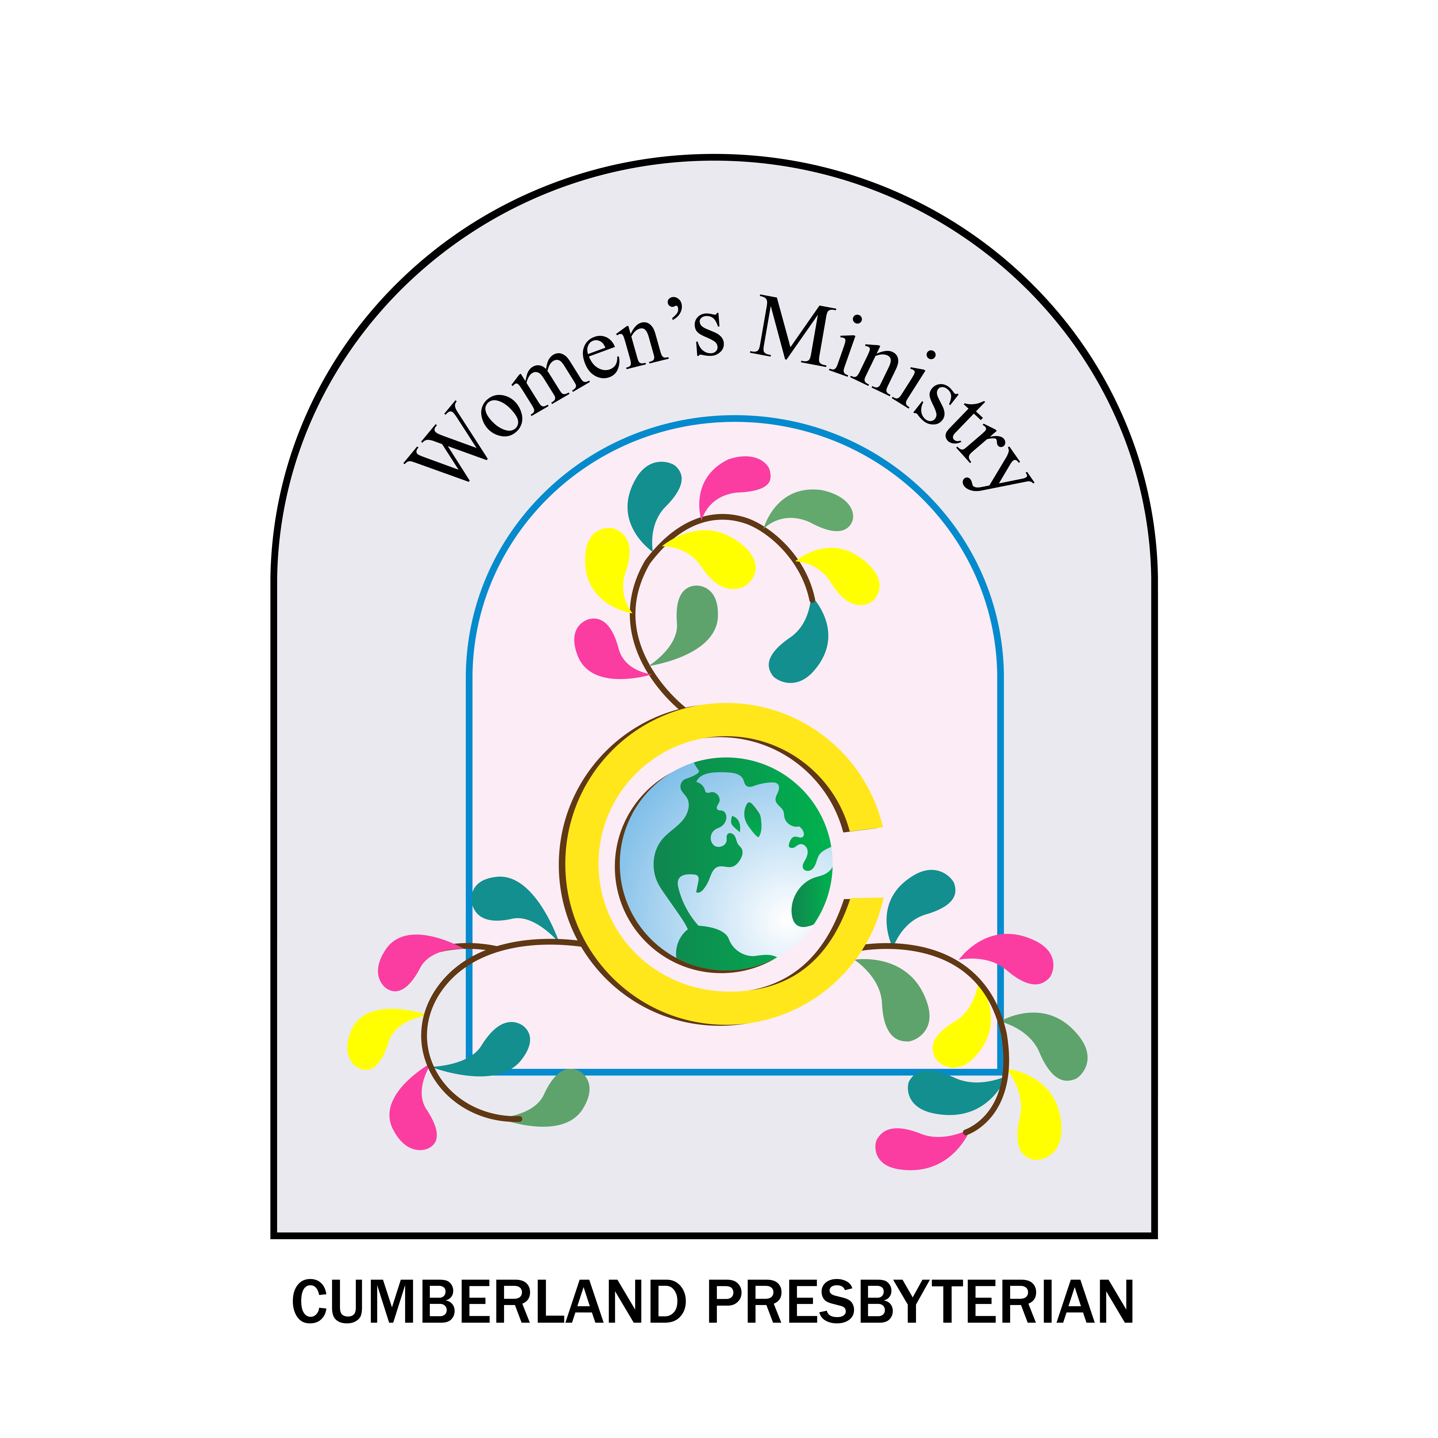
Endowments

Bestowed Membership
In grateful recognition of the fruitful years of service rendered to the cause of missions through the Cumberland Presbyterian Church
I (or we)
(person or organization bestowing membership)
wish to bestow a Membership on the following:

Name

Address

Memorial Membership
I (or we)
(person or organization bestowing membership)
wish to bestow a Memorial Membership in memory of the following:

Self-Membership
Name

In appreciation of the mission program of the Cumberland Presbyterian Church and in order that I may perpetuate my financial support, I wish to become a member of the Missions Ministry Team of the Cumberland Presbyterian Church.

Name

Address
 Perpetual Membership $ 30.00
 Diamond Perpetual Membership $ 50.00
(10 years of service in the Cumberland Presbyterian Church)
 Patron Membership $100.00
 Silver Patron Membership $125.00
(a woman with 25 years of service in the Cumberland Presbyterian Church)
 Golden Patron Membership $150.00
(a woman with 50 years of service in the Cumberland Presbyterian Church)

Total Amount Enclosed $
Application sent in by: Date to be presented: _
Please mail certificates to: _____________________________________________________
Address: ___________________________________________________________________

Mail checks payable to “Missions Ministry Team. Mail to 8207 Traditional Place, Cordova, TN 38016
Perpetual Membership
A contribution of $30.00 to the Board of Missions for the Perpetual Membership Endowment Fund by an individual or an organization entitles the donor or the individual specified by the donor to a Certificate of Recognition. A woman who makes such a contribution or is honored with such a gift is entitled to register as a Perpetual Member of her regional organization and the Convention with all the rights and privileges of a delegate.

Diamond Perpetual
A contribution of $50 to the Diamond Perpetual Endowment Fund by an individual or an organization entitles the donor or the individual specified by the donor to a Certificate of Recognition. A woman who make such a contribution or is honored with such a gift is entitled to register as a Diamond Perpetual Member of her regional organization and the Convention with all the rights and privileges of a delegate.

Patron
A contribution of $100 to the Patron Endowment Fund of any board or agency of the denomination by an individual or organization entitles the donor or the individual specified by the donor to a Certificate of Recognition from the recipient Board. A woman who makes such a contribution or is honored with such a gift is entitled to register as a Patron Member of her regional group and the Convention with all the privileges of a delegate.
A person may receive more than one Patron Membership. The money and information for a Patron Membership is sent directly to the board or agency giving the Patron Membership. Only those being given by the Board of Missions are sent to the Board of Missions.

Silver Patron
A contribution of $125 to the Silver Patron Endowment Fund of the Board of Missions entitles a woman who has served twenty-five years or more in the Cumberland Presbyterian Church to become a Silver Patron Member and receive a Certificate of Recognition. A woman who makes such a contribution or is honored with such a gift is entitled to register as a Silver Patron Member of her regional group and the Convention with all the privileges of a delegate.

Golden Patron
A contribution of $150 to the Golden Patron Membership Fund of the Board of Missions entitles a woman who has served fifty years or more in the Cumberland Presbyterian Church to become a Golden Patron Member and receive a Certificate of Recognition.
Any person who has served 50 years or more in the educational ministry of the church may become a Golden Patron Member of the Board of Christian Education and receive a Certificate of Recognition. A woman who makes such a contribution or is honored with such a gift is entitled to register as a Golden Patron Member of her regional group and the Convention with all the privileges of a delegate.
All Certificates of Recognition given for endowment fund contributions may be given to honor or recognize persons either living or deceased.

