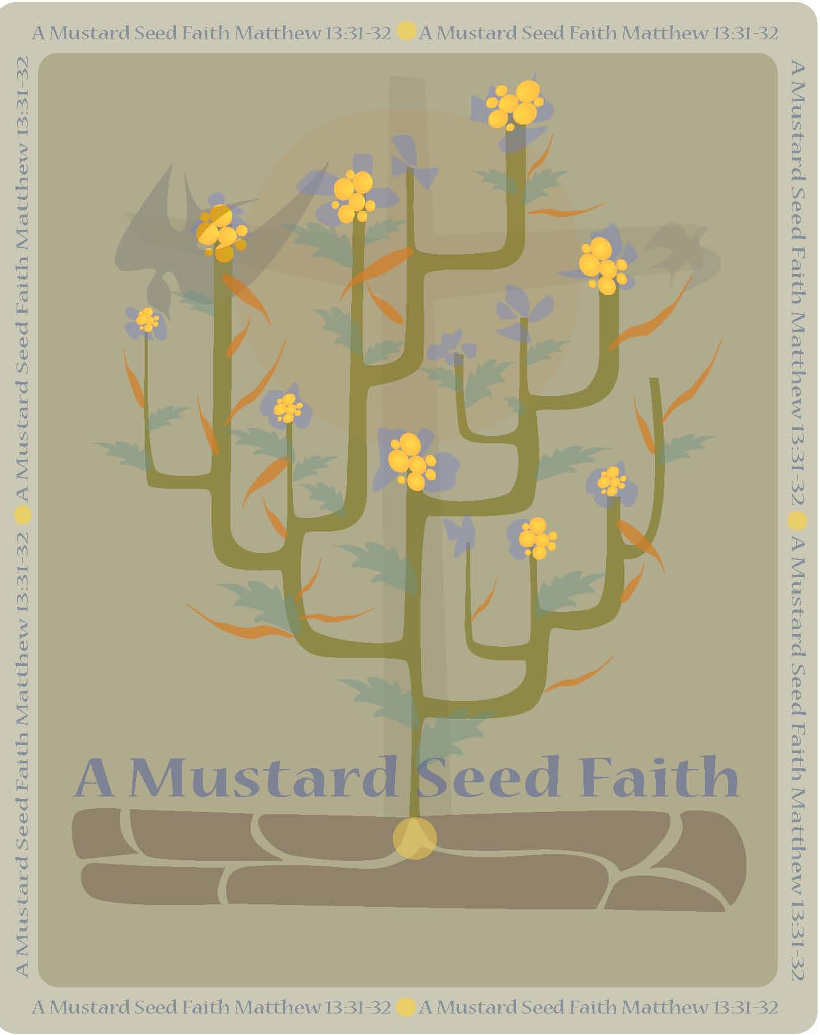
Louisa Woosley
A Mustard Seed Faith
Planting
Louisa Mariah Layman was born in central Kentucky on March 24, 1862. She married in 1879, to a farmer Curtis G. Woosley. Woosley struggled with a call to preach for most of her young life. Finally, in 1889, she was ordained as a minister of Word and Sacrament by Nolin Presbytery. Her ordination was contested by Kentucky Synod. Af several years of debate and argument, she was fully accepted as a minister in the CP Church. In 1916, she was elected stated clerk of Leitchfield Presbytery (Kentucky) and held that office for twenty-five years. She served as a commissioner to General Assembly three times and was elected moderator of Kentucky Synod in 1983. Woosley was very active in the Women’s Board and foreign missions. In 1924, she was awarded the first Perpetual Membership given by the Woman’s Board and later she was awarded the first Patron Membership in honor of her work for mission. Her ministry extended over a fifty-year period. By the age of fifty, her records indicate that she had preached 6,343 sermons, witnessed 7,664 professions of faith (adding 2,506 members to church rolls), and baptized 358 persons in 13 states. This great woman of faith, Louisa Woosley, died June 30, 1952. (from a paper written by Dr. Mary Lin Hudson, Professor of Homiletics and Worship at Memphis Theology Seminary, Historical Foundation website, http://www.cumberland.org/hfcpc/minister/woosleyL.htm)
Tending
A woman of faith, Louisa Woosley blazed a trail for all of us to follow. She was a remarkable woman who, unintentionally, laid the foundation for other women ministers, especially in the Cumberland Presbyterian Church.
A simple woman, she was a wife, mother and devoted daughter. She lived her life as a Christian woman raised in the Baptist faith. Her faith was strong and it allowed her to endure life’s trials and tribulations. She accepted her place in life and tried to fulfill what she believed was God’s destiny for her.
Louisa had never encountered a woman minister. She assumed that ministers had to be men. Therefore, when Louisa was called by God to preach the gospel of Jesus Christ, she didn’t know what to do. She was a wife and mother, a simple housewife with no formal education. In her book, she stated, “Not having so much as ever heard of a lady preacher and knowing that there would be opposition, I tried to persuade myself that it was not right for women to preach. I was uneducated and many obstacles were in the way . . .” (pg. 190)
However, God was more determined than Louisa. God repeated her call after she failed to heed his word the first time. God’s call the second time was much stronger. She knew that if she answered, she would face seemingly endless obstacles. But her word had been given. As her family and friends turned their backs on her, it was her commitment to God that gave her the conviction to continue in her quest. Even the very presbytery to which she wanted to devote herself, opposed her. But her faith continued to carry her forward, to carry out her work as a minister of Word and Sacrament.
In four short years, Reverend Woosley’s faithful work in the ministry of Jesus Christ carried her forward to preach 912 sermons, resulting in almost 2000 conversions. What a remarkable testimony on behalf of a woman who said she couldn’t preach.
Her life’s work opened doors for all other ministers to follow. How can anyone say that, “woman shall not preach?” with her remarkable example. She faithfully followed the voice of her God and He did not lead her wrong. In her quest to become a minister, she was forced to answer compelling questions such as the one above. As the male leaders of the ministry forced her to explain her faith and her calling, she was able to answer convincingly why and how God issued his special invitation for her to minister to others.
As she answered the questions about why she should be allowed to preach, her honest, heartfelt words began to reshape many of the closed minds of those who made up the Board of Inquiry. Her faith was formidable and her convictions made believers out of those who tried to doubt her calling. In the end, it was her simple words and answers that convinced the presbytery to honor her calling.
The answers that Reverend Woosley gave still apply to women today. Women are a part of God’s world. Through trials and persecutions, they have endured and risen stronger than ever. God’s work needs people of conviction. Gender is inconsequential.
Louisa Woosley led a life of obedience. Her faith led her to follow God’s words and it allowed her to lead many others to the church.
Faith leads to obedience. Joshua 22:5 says, “But be very careful to keep the commandments and the law of Moses the servant of the Lord gave you; to love the Lord your God, to walk in all his ways, to obey his commands, to hold fast to him and to serve him with all your heart and all your soul.” The passage is a powerful one that calls for “all” people to follow God’s words. Joshua, who was following in Moses’ footsteps, restates briefly the central message of Moses’ message from Deuteronomy. He reminds people that obedience should be based on love for God. In the passage, Joshua is reminding the Israelites of their spiritual responsibility and also their obedience to God.
Louisa listened to these words and while she had no difficulty with her calling, others did. Why did God call a woman, why not a man? The pressure from others often complicates our lives. But, Louisa made the decision to live God’s words. She did her best to ignore the opinions of others and devoted herself to being God’s servant. She believed that she was God’s chosen servant and she joyfully served God in her daily life.
When an objector told her one day that she was too weak physically and intellectually, she answered with the following, “God hath chosen the weak things of the world to confound the things which are mighty. ‘These all have to learn that it is, ‘Not by might nor by power, but by my Spirit, saith the Lord.’”
Faith gives us hope to believe in the unknown and to see the unseen. Hebrew 11: 1 reads, “Now faith is being sure of what we hope for and certain of what we do not see.” All of us have memories of some anticipation of surprise that was the cause of our excitement and that is the promise we hear in this writer’s words. Faith is the assurance of things hoped for and certain of what we cannot see. God’s plan for us is not always seen, but we must believe that what we do will be for God’s Kingdom.
Activity
Finish reading the other 2 verses and discuss what they mean to you.
Faith leads to salvation through Jesus Christ. Read Luke 19: 1-9. In verse nine Jesus says, “Today salvation has come to this house, because this man, too, is a son of Abraham. (10) For the son of man came to seek and to save what was lost.” Because of Rev. Woosley’s Gospel message, lives were changed. Her message brought salvation to many new converts. God, through Louisa and her preaching, reached those that needed to hear the message of salvation. Just as Zacchaeus on that fateful day needed to hear that someone loved him and was willing to forgive him, so did those who heard Louisa’s sermon. They too, had a changed heart.
Faith believes in miracles, as the Centurion in Matthew 8: 5-13 showed The Centurion completely takes Jesus by surprise as he requests healing for a servant who has fallen ill, when Jesus says he will go and heal the servant, the Centurion says to Jesus, “Lord, I do not deserve to have you come under my roof. But just say the word, and my servant will be healed.” Jesus was astonished and said the following to him “ I tell you the truth, I have not found anyone is Israel with such great faith.” We know the story ends with the servant being healed, but the part I want us to look at for a moment, is the part where Jesus says at the end of his statement; “ I have not found anyone is Israel with such great faith.”
The story of Rev. Louisa Woosley is one of great faith; she relied on God for everything and was not disappointed. Humans hurt her, but God gave her the strength to endure the hardships, which led to a successful ministry. The faith that she had is the kind of faith we need to carry out the ministry that God has called us to do as women and men of the Gospel.
Harvesting
Activities
- As a group, sing the hymn, Faith of Our Fathers.
- The Leader will need to have read this book ahead of time or have access to it for the study. In the book, Shall Woman Preach? Louisa illustrates the story of five women using a star. She calls this star, The Star Of Hope. This star illustrates to us the hope that comes to us through Jesus Christ. For your group have a star prepared ahead of time and list the women in your life who have given you love and encouragement during your times of trials. Discuss the impact they have had on your life and the hope you have because of their witness to you. (Shall Woman Preach, pg. 37)

Reflection Questions
  - What kind of courage does it take to stand up against the views that society has of women in the ministry?
  - Most importantly, what kind of courage does it take to stand up against your family and friends?
  - Have you had to give up family or friends to follow your calling? Or did you have to compromise?
  - Who are some of the women or men you have looked up to because of their faithfulness and or courage?
  - What does “faith” mean to you?

The story of Reverend Woosley is an extraordinary book, which serves as an inspiration for all women today. Women need to read and hear the message that this book speaks of, that still calls and encourages them to follow the One who will never forsake them on their journey in life.
Celebrating the Bounty
Prayer: Loving and gracious God. Thank you for the opportunity to share our hope and faith with others. Forgive the times when we show our lack of faith while facing seemingly insurmountable obstacles. Help us to find the courage to stand and renew our strength as we look to you and to our sisters and brothers of the faith for comfort and support. Bless these that have gathered in your presence. May you bless them in the Holy and Righteous name of Jesus our Lord. Amen.

Rev. Dr. Virginia Espinoza is an ordained Cumberland Presbyterian minister and resides in Boswell, OK with her husband Pat. Dr. Espinoza pastors two small rural churches, the Pigeon Roost CPC near Boswell, OK and the Rock Creek CPC in Honobia, OK. Virginia is a mother of three children and grandmother of six grandchildren. Included in her family are six step-children. Dr. Espinoza works for the Choctaw Nation of Oklahoma as a Distance Learning Instructor, she teaches the Choctaw language to high school students via satellite. Virginia loves teaching and sharing the gospel with anyone who wants to hear.

