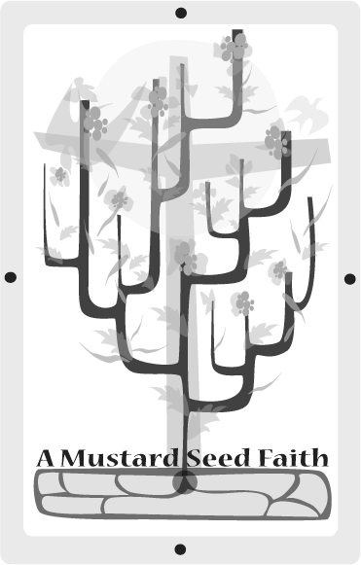
The Widow at Zarephareth’s Last Meal
I Kings 17:7-24

Open with the praise chorus Open My Eyes, Lord, then pray that God will touch you through His word and transform your life today.

Preparing the soil
God doesn’t call the equipped - He equips the called. Consider Gideon in the Old Testament. (Judges 6:12) What person today would call a cowardly man hiding in a winepress a "mighty warrior?” God did because He knew His plans for Gideon. What about the woman at the well in the New Testament? (John 4:4-42) Would you choose a woman who had been married five times and was currently living with a man who was not her husband for a candidate to lead a religious revival in a town? God did. God knew her mustard seed faith. God has used simple, often nameless people. God has not changed.

In the musical Chicago a character sings a song with this chorus…"I’m Mr. Cellophane, Mr. Cellophane. Nobody knows my name; I’m Mr. Cellophane. They walk right by me, look right through me---they never know I’m there!" In today’s fast-paced world, throwaway society, we often feel this way. God does not see us this way. God has chosen to include us in His plan to redeem and restore the world. Rise up, sisters in the faith; armed with your tiny faith the size of a mustard seed, submit yourself to God and prepare for the ride of your life!

Planting
The word of God is alive. When planted in our lives it grows, matures and bears much fruit (John 15:1-8). Today’s lesson is about a nameless widow, a small child, and a beginning prophet of God who can be powerful when focused on God and impotent when he takes his eyes off of God. What an unlikely crew---kind of like us, eh?

Read I Kings 17:7-24

Tending
Elijah has just been sent to King Ahab. Ahab is the evil King of the northern portion of the now divided Israel. To prepare him for the next event, God has sent him into solitude where ravens feed him and where he is provided water, in this land of drought, by a gurgling brook.

When God’s timing, which is perfect, comes about, the brook dries up and Elijah is sent to Zarephareth where he is told he will find a widow. As God provides for US each day, how often do we take this as a "given” or that we are just "lucky?" Elijah obeys and goes to finds the widow as prophesied to him. If the Holy Spirit does not go before you, you might as well not go. Elijah asks for a sacrificial, off the top, offering from the widow. By today’s standards of media preachers of the "God wants to make you wealthy" mentality, this should have made the widow healthy, wealthy, and wise; and perhaps even the queen of her village. God rewards the widow’s faithfulness. How often do WE give of anything - time, possessions and talents, until it hurts?

Then the unthinkable happens! Why do bad things happen to good people? We do not have the mind of God, nor do we have God’s scope of vision. We must keep focusing on HIS PLAN so we can better understand and accept how He is using us. )
Question:
What was the result of God using these people? (Read verse 24)

Harvesting
Even though the scriptures were not written TO us, they were written FOR us. God is alive. He does not change. God still works in the lives of people to accomplish His will.

Apply what you have learned from this scripture to your life today. Divide into small groups so everyone will have a chance to say something about each question. Remember, not all our answers will be alike. Our answers will differ because of our education, life experiences, and where we are in our walk with Christ. We can learn from EVERY answer, though.

1. Share about a time that God asked you to do something you thought you couldn’t do? What was the result?
2. Have you ever engaged in an activity without asking God? What were the results?
3. What was so special about Elijah that God chose him?
4. What was so special about the widow that God chose her?
5. Have you ever felt that God has placed something or someone on your heart? Explain.
6. When we don’t use the "gifts God has given ALL of us,” what happens to the workings of the body of Christ? (I Corinthians 12:2-14)?
7. When we "humbly" say we have no gifts, what does that say about God, who says we DO?
8. What if we do what God tells us to do, but things don’t turn out like WE think they should?
9. Which is more important to God, your ability or your availability? Explain.
10. How does God take our faith, which may be small as a mustard seed, incomplete and imperfect, and do amazing things with it?

Celebrating the bounty
Look around the room at those in your group. Pray that God grows the seed of His word in each of our spirits so that that we may boldly offer Him our mustard seed of faith each day.

Pray for -
1. Growth and maturity for you to be a woman after God’s heart.
2. The growth and maturity of your church.
3. The salvation of your family and friends.
4. God to use YOU in His plan to redeem and restore the world.
5. Yourself – that you will be an instrument in bringing America back to God.

Close with one of the following songs:
O’ For A Thousand Tongues To Sing
Take My Life And Let it Be
I’ll Go Where You Want Me To Go
Savior Like A Shepherd Lead Me.

Jeanne McCutchan is a retired schoolteacher and counselor. Since "retired' she can now quicken her race for God. Jeanne works in her church, an international ecumenical Christian community called Tres Dias. She is also active in ministry in local nursing and retirement homes. She also volunteers in the community by tutoring in a school two days a week and by ushering at performing arts events and helping with the local Tourist Information Bureau.

