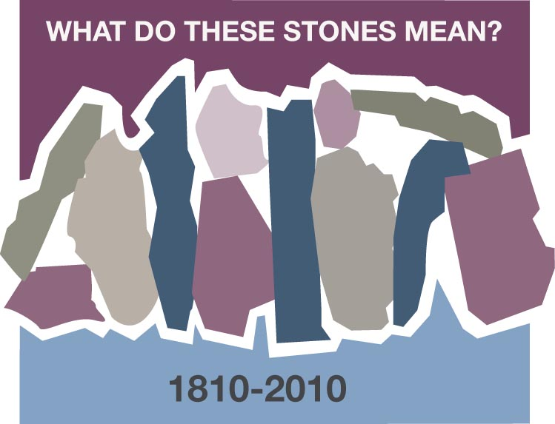
WHAT IS AN “EBENEZER”?
Tana Sue Lawson, McDonald, Tennessee

It was our regularly scheduled Wednesday night choir practice – nothing special, except the people of course! As we practiced a new arrangement of “Come Thou Fount” we began to discuss “just what in the world was an Ebenezer”. We quickly determined it wasn’t Scrooge that was being raised up! But what was it?

So the challenge went out for someone to research this and report back the following week. Kay took the challenge, and we moved on with practice. Mind you, our practices were anything but boring with Kay in attendance. She’s the funniest lady that I’ve ever had the privilege of knowing. She’s the one that I convinced to do a skit for our Women’s Retreat (without telling her there would be over 150 in attendance) and then once she got over her nerves and took the microphone I began to wonder if I would ever regain control!

But then there’s the serious side of Kay as well. The side that would take you on a Bible study that quickly became a journey in itself – she loved to go down rabbit trails and see where you could end up. You see Kay is the one who taught me that when someone comes to mind it’s then that I’m to stop and say a prayer for that person because “that’s holy ground your standing on”. This has proven to be true more times than I can even tell you; and it never ceases to amaze me. When I find out that the person I said a prayer for last month was actually in ICU at the local hospital in serious condition. Or that someone else was going through a very difficult time with family crisis. Sometimes you may get to know why you were allowed the honor of praying for someone and other times you may not.

So, back to Wednesday night choir practice … as we gathered together the following week Kay was there with the smoothest little stones for each one of us. Of course we had no idea where she was going but were all quite interested to find out just what she was up to this week! And yes, we had forgotten that she had accepted a challenge the previous week. She began to explain that the stone was our “Ebenezer” the stone to remind us just who our Savior is and what amazing things He has done and continues to do for each of us.

She then challenged us: “Keep the stone where you can be continually reminded to give thanks and praise to the One that has given His all.” Mine sits at my desk at work where I can see it every day and where I need most to be reminded to give Him praise. I know one other person who has the stone in their pocket most days so that when they put their hand in the pocket they remember.

In December 2009 Kay was diagnosed with cancer and in January 2010 she had the honor of going home to be with her very personal Lord and Savior. To say I miss her would be the greatest understatement I could make. But to say that she’s a stone along my faith journey – oh yes she is! So in honor of Kay, I leave you this question: Where is your Ebenezer?
Discussion and Reflection Questions
Scripture: 1 Samuel 7: 11-12 and Philippians 3: 13b-14

Tana Sue Lawson takes us on a very personal journey with a very special friend. In this study we met Kay, a very humorous and insightful friend who loved to get to the bottom of little mysteries in life. Keep in mind the stones in Joshua 4: 1-9 that were placed along a pathway that God's people were traveling as a marker and a help.

"Ebenezer" is used as a symbol to remind us of Jesus and all He has done for us. When she presented the choir group with the smooth stone, little did they know that Kay would leave them soon for a better world. The Ebenezer stone represents a new beginning with God's everlasting mercies and a covenant that lasts forever.

Tana Sue also reminds us of the moving of the Spirit in bringing person's names to mind when they are in need of prayer. We should never ignore these nudgings of the Spirit when they come to us at odd times, maybe in the middle of the night.

Questions:

First let's look at Tana Sue's question: " Where is your Ebenezer?"

Do you carry, or keep near, any object that reminds you of Jesus? If so, what is it?
(It does not have to be a stone. It could be a journal.)

Have you ever found yourself awake at night with someone particular on your mind and later found that the person was in need in some way? Did you share this with them or their family? Share your experience with a neighbor.

How do we distinguish between the indwelling of the Spirit and coincidence?

Prayer:
Holy Father, may we always seek to stay near unto you, to listen for your "still small voice". We thank you for those who come into our lives at very special times and who minister to us, or to whom we are guided to be with either in prayer or in person. Use us, Father, in special ways to be stones along others' faith journeys. In Jesus precious name we pray. Amen

