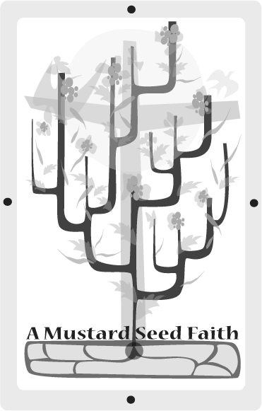
Rahab’s Red Cord
Joshua 2:1-21

Planting
The book of Joshua introduces us to one of the most amazing women of the Old Testament. The purpose of this lesson is to understand how to be someone who has faith to change the situation around them. Rahab was a prostitute who through her faith saved herself and her family by befriending spies sent by Joshua to case out Jericho. She was only one person but made a large impact. As a tiny mustard seed grows into a huge bush, so can one woman change the lives of many. Read the scripture from The Message as well as the NIV to better understand the story. Find background material about the city of Jericho, the inn where Rahab lived, Rahab’s family members, and the men who were sent to spy out the lay of the land. Buy enough small red cording from a fabric store to make enough red cord bracelets for each of your members.

Tending
Have a good storyteller relate the story of Rahab and the spies.

Ask the following questions:

- How did Rahab learn about the Israelites? Why do you think she was on their side?

- Why do you think the Israelite men wound up at this prostitute’s house?

- Why do you suppose God used such a person as a prostitute to show faith?

- Do you think it was all right for Rahab to lie? Why or why not? Is telling a lie ever a good thing? Explain your response.

- What do you think we can learn from Rahab’s actions?

- How do we show our faith?

- What things try to come before our faith in God?

Harvesting
Grand things can come from little actions. There are several actions to take relating to this lesson. Go to the internet website www.rahabministeriesthailand.org. You will find ways to support this organization. Also, the website http://mustardseed.org has several ways to interact with this organization that exemplifies the theme for this year. On the local level contact a women’s shelter to find out how your organization might help.

Celebrating the Bounty
For fun teach the members this song to the tune of B-I-N-G-O:

R-A-H-A-B
There was a girl God used for good and Rahab was her name – O
R-A-H-A-B, R-A-H-A-B,
R-A-H-A-B
And Rahab was her name – O.

Give each member a red cord bracelet. Tell them this bracelet should remind them to take actions to help someone because “Grand things can come from little actions”.

Close with prayer: God, our help in all we do, hear this prayer. Make my actions in my world cause grand things to happen. In our Father’s name we pray. Amen

Janey Edwards is a lifelong Cumberland Presbyterian at the First CP Church in Savannh, TN. She is a retired school teacher having taught middle school and high school for over 40 years. She teaches an adult Sunday school class and is president of the local CP Women’s Ministry. She has two adult children who are also lifelong CP members at Savannah First. You can contact Janey at janedw2@charter.net

