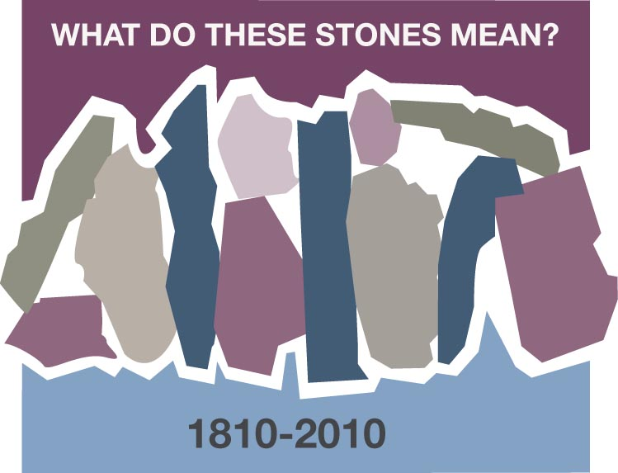
A MOUNTAIN: MY STONES
Nona Thomas, Birmingham, Alabama
As I sat in my living room in Manizales, Colombia looking out the window my eyes did not see the streaming golden sunlight that usually gave me comfort in the quiet of the morning. As I was sipping my hot tea to soothe my sore throat, I moved closer to the window to ponder where had the sunlight gone. As I adjusted my eyes I saw black snow, which seemed weird to me but it was actually volcanic dust. I turned on the radio to hear the warning that the Volcano Nevado Ruiz was spitting out ashes and that we should all stay indoors that day. The doorbell rang, I answered, and there was a masked man, it was just the milkman delivering the milk for the day, but it sure scared me. I decided to close the curtains, lock the door and read my Bible.
What is this stone? Trust God with all your heart.
Reading in Psalm 3 for comfort I read “O Lord how many are my foes” a sore throat, volcanic ash, and the Colombian drug lords were blowing up buildings. “How many rise up against me. Many are saying of me God will not deliver him. But you are a shield around me, O Lord; you bestow glory on me and lift up my head.” Friends and family were telling me to come home to America where it was safe. The Colombian women were relentless in their encouragement to the young American missionary. They would bring me gifts, make me hot chocolate and send me fresh flowers. They loved me, and my family, and told me over and over how they had prayed to God for a missionary family.
What is this stone? God listens.
“To the Lord I cry aloud, and he answers me from his holy hill.” I knew the volcano that was making it rain black dust was also a picture of strength in my mind. I would cling to that image of God’s strength. I cried out to God-“Give me your strength.” In Psalm 121 these words etched into my mind this particular day “I will lift up my eyes to the hills where does my help come from? My help comes from the Lord who made heaven and earth.” I looked outside into the dimness and not seeing the mountain I looked up in faith knowing it was surrounding me reminding that God’s presence in our lives is the rock that we embrace as we journey through life.
What is this stone? God is faithful.
A few months passed and once again I was lifting up my voice saying “Give me strength and surround me with your presence” The local army base had an explosion earlier in the day shaking the windows throughout the house. I was a little nervous and nine months pregnant. While preparing dinner, I sliced my finger with a knife and the throbbing pain from the deep cut was constant but when I laid down, I felt the peace of God and fell asleep. Through a series of miraculous events our daughter was born at home later that night without complications and in perfect health.

What is this stone? God is with us.
My soul focused on the rock outside my window throughout my years in Colombia. Friends and family were in awe of the events that took place in our lives. The rock stayed firm through a tonsillectomy and the early birth of another child all on the same day. (This was not the plan, the third child just decided to come since we were already at the hospital. Unfortunately, we were at the wrong hospital for childbirth)
What stone is this? God is a fortress.
When contractions began at six months of pregnancy, I clamored over and over for the life of the unborn child. My body was ill. The hospital had a staph infection, I was sent to a small clinic not equipped for the birth of a premature baby. My God and my stronghold healed me, and my son, Caleb Josiah, who was born at full term.
What is the stone? Jehovah heals.
My rocks, the stories I tell my children, my friends and my faith family are meant to be altars that remind us of God’s faithfulness, of God’s awesomeness of God’s healing power, of God’s strength. Each of these testimonies is meant to bring glory to God.
So what are the stones in your life that bring glory to God?

Discussion Questions and Reflection Activities
Scripture: I Cor.10: 1-4

In Nona Thomas's reflection on her time spent in Colombia as a missionary, she summons up five powerful images of God as our "Rock". In each of these episodes, Nona was provided with the strength, courage, and healing that she needed to carry out the work God had sent her to do. When we review them: "Trust God with all your heart," "God is faithful," God is with us," "God is a fortress," and "Jehovah heals," these images summon to our minds and hearts, times in our own lives when we depended on God in each of these ways.

Questions:
Taking each "rock" one at a time, give your members opportunity to share instances when God provided this type of guidance and protection for them.

Can you give the "Rock" any other names through which He has enabled and guided you during a critical time? Write these names on newsprint or chalkboard.

Prayer:
Give thanks for the times when God has been the "rock" on which you could depend, no matter what was happening. Ask for guidance in sharing this witness.

