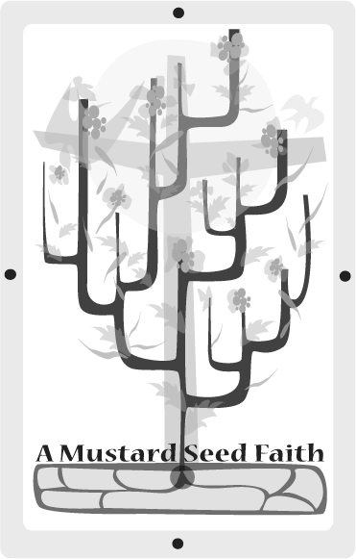
Lydia
Acts 16:11-16, 40

Planting
Lydia was a successful business woman from Thyatira. She was a seller of purple. She worked hard at her job and had many working with her. She lived well and had a big family. She was a believer and when Paul came to her area, she heard him speak at the river. Lydia became one of Paul’s first converts and shared her faith with her family and workers. She was one of the first evangelists. She had needed someone to water the tiny seed planted in her heart. Paul was the watering can God chose to use. As a born-again Christian Lydia then became a faithful servant for the furtherance of the gospel. She brought many to Christ.

Tending
Ask a businesswoman or a person who loves purple to dress completely in purple and relate the story of Lydia, her conversion experience, and evangelism activities. Supply the storyteller with several pieces of purple cloth (enough for each person to take with her). Suggest that the speaker start out by asking if anyone would like to buy her purple. Use the following websites to get background material for the story: www.onmission.com (type in Lydia, Somebody in the search line), www.keyway.ca (type in Lydia in the search line). and www.heartsforchrist.org/womenofword/lydia1.htm.

Harvesting
Several ways are available to you to be a Lydia in your community. Each day find some way to show your faith to others. When you are at home or at work or at school or wherever you find yourself daily share your faith. This may be done in conversation or in actions. Wearing a smile, opening the door for someone, giving a hug, telling the cashier she is doing a good job, taking a neighbor some muffins, calling a shut-in, sending a homemade card, or giving positive reinforcement to children or young people are just a few ideas of sharing your faith. Also, the website www.lydiahome.org has direction how someone can be a Lydia in the world. The smallest seed of kindness may cause tremendous growth in someone else’s faith.

Celebrating the Bounty
Choose one of the following activities to close this session.

1. Teach the following song about Lydia. This can be heard at http://gardenofpraise.com/bibsong62.htm

Tune: "We Shall See the King Someday"

Verse 1:
One time in the night Paul had a vi-sion clear.
God was call-ing him that way.
A man from Ma-ce-do-nia said, "Come help us here."
Paul o-beyed with-out de-lay.
Chorus:
They went to Phil-ip-pi and then
On the Sab-bath went to pray
By the riv-er-side.Some wo-men were there too.
Ly-di-a was there that day.
Verse 2:
She was a fine mer-chant, sel-ler of the cloth.
Roy-al pur-ple was her ware.
As she lis-tened to the mess-age Paul would say
God would o-pen her heart there.
Chorus:
She was ea-ger for Paul's words.
She be-gan to trust in him.
She was bap-tized with her house-hold in the Lord.
And o-pened up her home to them.
2. Give each woman a piece of purple cloth, telling them to pin it to their visor in their vehicle. This will remind them each time they enter or exit their vehicle to share their faith in God wherever they go. As Lydia was successful in converting many to Christ maybe they will be, too!

Janey Edwards is a lifelong Cumberland Presbyterian at the First CP Church in Savannh, TN. She is a retired schoolteacher having taught middle school and high school for over 40 years. She teaches an adult Sunday school class and is president of the local CP Women’s Ministry. She has two adult children who are also lifelong CP members at Savannah First. You can contact Janey at janedw2@charter.net

