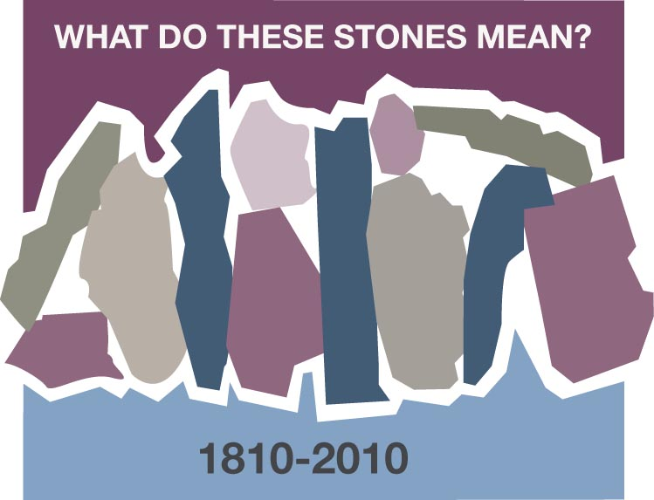
GOD’S WORD
Luz Maria de Montoya, Pereira, Risaralda, Colombia

When I received Christ in my heart, God awoke in me a love and a desire to study his word. During the process of being discipled and growing spiritually I learned to study the word every day, and I also learned to mark my Bible with the date when God called my attention to a particular text in order to console me, exhort me or remind me of a promise that would sustain my faith.

While thinking on the theme chosen to celebrate the bicentennial of the Cumberland Presbyterian Church: What do these stones mean? and bringing it into the context of my faith walk with God and his word, I can truly say that each text, each verse, that I have marked in my Bible with a date (and I’ve had to change Bibles several times over the years), each of them are texts that have sustained my faith and my hope during times in which I needed to “remember” that God has always been there as my Good Shepherd, helping me and walking with me even in the darkest of valleys.

Those texts that marked in my Bible have been as “stones” that make me remember and celebrate each new evidence of God’s constant love and care for me, and my family. They have also strengthened my faith in times of anguish because they remind me that what God has done yesterday, he can also do today – how wonderful! How many stones have we been able to place that help us remember God’s wonderful works and thus enable us look toward the future with hope!

These “stones” have been reminders to speak and share with my children of the love and faithfulness of God. I have four, and when, during my second pregnancy I was informed I was carrying triplets, my first thought was to tell God that I accepted his will, but asked only that his care and provision for us would never be lacking. God has been greatly faithful and good, but when in temporary difficulties I turn to my Bible and look for “my stones” so I can talk to my children and remind them of God’s provision; I can tell them and show them in my Bible exactly when I marked the words that God has used to speak to me and tell how he has come through for us. For example, I remember when he miraculously moved someone’s heart to send us a check to buy shoes, because God told his servant that he watches over the birds of the air and would also watch over his servant’s children. The same happened when he consoled me telling me not to worry about money to pay for their university studies, because he would defend my cause and take care of my children. Yes, I am a woman who can tell of God’s love and power, and I don’t want to ever forget or allow my children to forget. That’s why I talk to them and take advantage of every life-lesson or need to show my “stones” to help them “remember” who God is and what it means to be under his grace and mercy.

I want to end this by saying that I sing with the psalmist when in Psalm 119: 49 –50 he says:
Remember your word to your servant, for you have given me hope.
My comfort in my suffering is this: your promise preserves my life.
(Today’s New International Versión
Yes, in each word, each promise, God has given me life and I want to write and keep his promises and word as “stones” in my heart so that they may always be with me and remind me of what great love God has shown to me, so that when anyone asks the reason for my hope and faith I, like the children of Israel, can tell and remember the story of his wonderful love and mercy.

Discussion Questions and Reflection Activities

Luz Maria Montoya speaks from a faithful heart as she tells of being true to her resolve to study God's word, always marking the passages with the date when they were read. As she raised her children they were guided by their Mother's testimony. The Scriptures had sustained her during times of anguish and turmoil as well as in times of triumph and happiness.

Questions:

After studying the passage from Joshua 4: 1-9, when have you built a monument to honor God that has endured throughout your lifetime ( or that you wish to last a lifetime)?

When in your life have you made a promise to God that has sustained you throughout the good times and the rocky times?

Do you have a favorite story from a parent or grandparent's past that marked a milestone of faith as he or she faced life's river crossings?

Prayer:
Close with a prayer thanking God for his everlasting faithfulness, for caring for us even when we have neglected our promises to him, for strength to do the hard tasks that are set before us, to be able to discern his will for this group who comes together in his name.
May God continue to bless you in life's journey.

