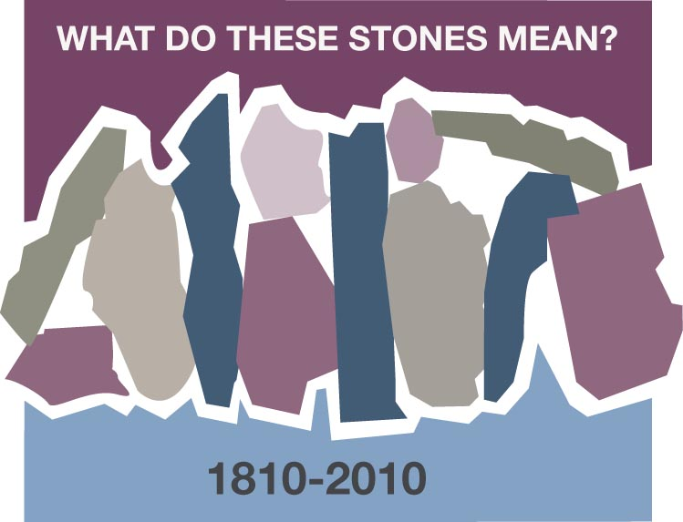
CUMBERLAND PRESBYTERIAN YOUTH CONFERENCE - 1992

Jill Carr - Lebanon, MO

Where I live, we don’t have stones – we have rocks. I grew up on a farm and was a tomboy. I know rocks. I played with them and collected them, but rocks are an enemy on a farm. “Picking up rocks” or going to “pick rock” was a dreaded, and seemingly unending, chore. My dad would hook up the tractor and trailer, and we’d go to a field which needed rocks removed. My mom, sisters and I would commence to pulling up rocks from the ground by hand while my dad would use the pick to loosen rock that was just under the surface. When the area was picked clean or the trailer was full, we’d take the load to the rock pile, a pile of rocks in a spot of unusable pasture, and begin the process of unloading all the rocks we’d just loaded. It could be back breaking work - hot, dirty, long, tiring – but necessary. My dad has a system for working a field, and by the time he’s done, the ground is perfectly level and the soil is as fine & smooth as silk. The first step is picking up the rocks.

When I read the story of the Israelites crossing the Jordan into the Promised Land, I picture the priests standing in the riverbed, holding the Ark of the Covenant for hours & hours & hours without moving. I picture a sea of people who are anxious, and perhaps tired and hungry too. I hear the noise of animals bleating, mooing, neighing, & grunting. I hear the rustling of trees and grasses. I feel the anticipation. It had to be back breaking work for 2 million people plus livestock to accomplish this one task – hot, dirty, long, tiring – but necessary; necessary to complete their journey; necessary to begin settling their own land; necessary to give Joshua the credibility he needed to lead the Israelite nation; necessary to fulfill the promise God had given.

It is difficult to only choose one stone out of the riverbed (or one rock from the field) to memorialize as significant in my faith journey. I can picture the rock pile from my childhood and the size of it seems much more representative of the many things that have shaped my life. Each rock from that rock pile could be a person, or situation, which honed my thoughts, my attitudes, my actions, and my heart to be more the person God made me to be and continually calls me to be. I choose a rock that, when pulled from the rock pile, creates an avalanche of grace and peace and blessings.

My rock is the Cumberland Presbyterian Youth Conference (CPYC) in 1992 when I served on staff as a member of the worship team. It was a week of making friends with other staff who have since journeyed with me in faith, providing comfort, encouragement, or laughter as needed. It was a week of awakening to God’s call on my life, which altered my career path and prioritization of time and resources. It was a week of God speaking to me through the scriptures, not specifically about each one that I read in worship daily, but through them collectively letting me know that God was a power in my life that I couldn’t avoid. The changes that ensued were ones that I didn’t plan, didn’t expect, and didn’t quite know how to accept.

My stone story is not one that would captivate most, but it is the pivotal time in my faith journey. I can picture the faces of those who were there. I can hear their voices encouraging me. I can feel the tears on my face as I read scripture in Hull Chapel to a crowd of silenced teens. This is the stone about which I tell my child… as well as all the youth with whom I’m privileged to journey alongside.

Recognizing God’s hand during the journey is tricky. Acknowledging God’s hand is humbling – but necessary. We must claim it, memorialize it, and tell our children about it. The first step is picking up the rocks.

Discussion Questions and Reflection Activities
Scripture: 1 Cor. 10:4

When we reflect on Jill Carr's message we need to visualize a very rocky terrain much like we have probably envisioned for the Promised Land. Haven't you always wondered how the Israelites ever were able to farm or plant vineyards, etc.? With Jill's help we now know that it is only after many days of back-breaking, diligent work that the ground is ready to grow bountiful crops.

Even so, the Rock on which we build and grow this year may have come only after serious and agonizing meditation and prayer with many mistakes along the way. Our faith journey never proceeds without choosing just the right stone that will yield blessings, grace and peace.

Questions:
When have you had a pivotal spiritual moment that you know changed your life forever?

If church camp is a part of your background, either from the standpoint of being a camper or a leader, what stone was overturned there that led to a new dedication and/or purpose in your life journey?

Are you struggling with some task right now that seems more like "Rock Picking" than a smooth transition in the growth of your circle, congregation, or personal commitment? Spend some time with a friend talking about your “rock picking” journey.

Prayer:
Thank God for the obstacles in your life that turned into blessings. Ask for strength for the journey in whatever phase of your growth you find yourselves. Thank God for this strength and for His grace, blessings and peace.

