The Hem of Jesus’ Robe
Mark 5: 25-34

Planting
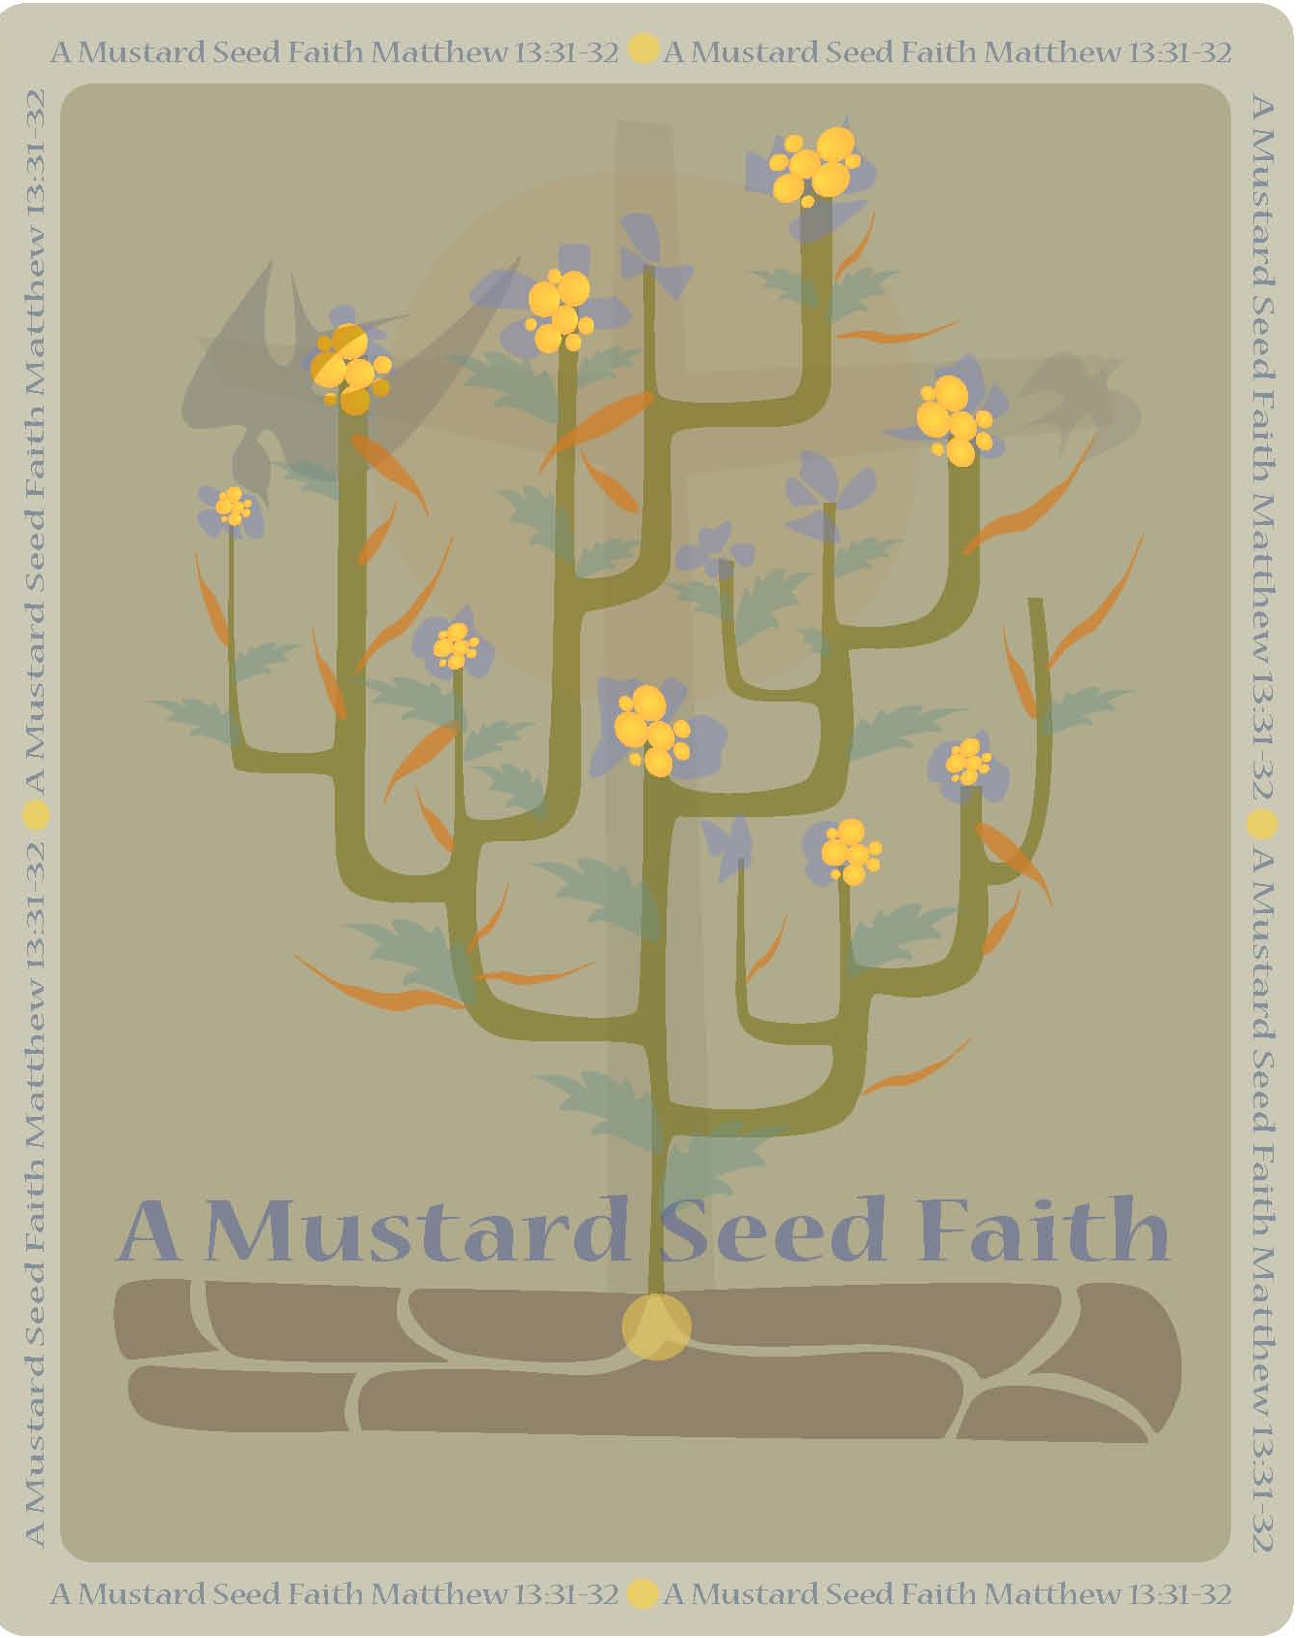
The world is a cynical world. People in general don’t believe in everyday miracles. In this world of “show me and I will believe,” this story from Mark calls upon us to look at it through the eyes of faith. This is about witnessing to believers as well as to unbelievers. It is up to us who believe in miracles to witness to those who have yet to believe in the One who still deals in miracles.

The woman who believed that just touching the hem of Jesus’ robe would heal her showed a great deal of faith but the story is not about the garment healing as much as it shows us that Jesus is the healer. Jesus not the garment is the healer, and not just our physical body but also our spiritual body. To be completely well is to be healed body and soul. The woman’s faith led her to Jesus, led her to reach out to the last person who she believed could help her. All of her physical resources were gone, the physicians had done what they could for her and yet she was not healed. Jesus was her last resort.

Tending
The Church is often referred to as a woman, such as “the Bride of Christ.” As such, let us look at the issue of blood or hemorrhaging as Mark calls it. Scriptures teach us that life is in the blood of a person or animal. In Genesis 4: 19 God says to Cain, “What have you done? Your brother’s blood cries out to me from the ground?” Life had been taken away and God called upon Abel to atone for it. That is the reason Jesus shed his blood, for by giving His blood he gave his life for others.

As we look at this passage let us look at this story as if this woman represents the Church. If looked at this way it means that the church is slowly bleeding to death and the only hope we, the church, have is to touch Jesus again. There are people today, and in communities throughout the country, that are bleeding to death. The only hope and one answer they have are to touch Jesus. By reaching out to touch the hem of Jesus the Church can began the restoration. The world needs to touch Jesus and touch others with the healing power of Jesus Christ.

In addition to the issue of blood, we might ponder what other issues did this woman have in her life? Let us place ourselves along side this woman because her issues may very well be ours also. We will look at some issues that apply to us today. What are the issues in our lives that need healing?

1. A physical issue:
The issue of blood was a physical issue. This woman suffered for twelve years. Everyday, every hour, every second, she was aware of her physical condition. As women we may be able to relate to this illness and know the lengths that she went to ease the suffering. Maybe there is someone sitting in your circle that knows how this woman felt or maybe there is an illness in your family that has drained and exhausted you. The hopelessness and despair can be very overwhelming and when all hope is gone and we have nowhere else to turn then we reach out and touch Jesus. Touching Jesus is all that matters, for Jesus is the healer of all our illnesses. We must understand something very important here. God is never late. God does not work on our timeline. Living in this world we live under natural laws and natural laws are controlled by time. In 2 Peter 3: 8, he writes, “…With the Lord a day is like a thousand years and a thousand years are like a day.” God has a perfect time and the impossible becomes possible when God’s perfect time meets our natural time.

2. A financial issue
The second issue the woman had was a financial issue. If we have had an extended illness we know what that can do to our financial status. The medical treatment was very crude for a woman in this culture evidenced by the following excerpt from a rabbinical book quoted by Lightfoot: “Let them dig seven ditches, in which let them burn some cuttings of vines under four years old. Let her take in her hand a cup of wine; let them lead her away from this ditch and make her sit over that. Let them remove her from that and sit her over another. At each removal you must say to her, ‘Arise for they flux’.” This is an illustration of what this woman suffered. The tragedy was, she did not get better but rather her condition worsened. She was also broke.

Today we could say she sold her house, car, TV, furniture, jewelry - everything she owned. She had no more resources, no CD’s, no savings, NOTHING, nothing was left. We can all relate to that and we can feel the despair.

This is where grace and mercy came to her through a man called Jesus, her only hope. In 2 Corinthians 8: 9 Paul writes, “For ye know the grace of our Lord Jesus Christ, that, though he was rich, yet for your sakes he became poor, that ye through his poverty might be rich.” Jesus came so that we might have life and have life abundantly. We must understand the verse above is not only for our spiritual existence but for every area of our lives; whether it is our spiritual, physical or material existence, God wants to treat us better than we deserve.

3. A family and friends issue
In Leviticus a woman with an issue of blood was regarded as unclean and anything she touched was unclean. (Leviticus 15: 19-27) For twelve years she was an outcast. She knew how it felt to be cast out of the community. She knew the loneliness of being ignored and shunned by people, even, the women who had once been her friends. She knew loneliness especially if she were married. For twelve years she was not allowed to touch her husband or her children, if she had children. She was not allowed to walk in the streets where there were people. She was not allowed to sit on anything in public places. No one dared to come and visit her. She was all alone in the world. In fact, the law decreed that if she was caught in public, they a right to kill her.

In her approach to Jesus she took an overwhelming risk. She dared to come to him in the midst of the crowd and then she dared to touch a man, even if it was just the hem of his garment. Her act was punishable by law, yet for her a death sentence had been passed on her for twelve years and she had nothing to lose and everything to gain.

4. A faith issue
The last issue had to do with faith. How many of us can relate to this? How many of us today realize that after twelve years of loneliness and being shunned by her community that she would have a faith problem? With each passing year, day, month, hour and moment her level of faith grew smaller.

Maybe you also have a faith issue. Maybe you, too, feel it’s not worth the trouble to believe anymore. Maybe you are just going through the motions each day and each Sunday as you sit quietly in your pew and wonder what you are doing there? If so, then listen, reach out and touch the hem of Jesus’ garment and renew your commitment to him. Life will never be the same for you again.

I thank God that God is only looking for faith as big, or rather as small as a mustard seed. With faith the size of a mustard seed your life will take on new meaning and vitality.

There are two things that stand out in this story: 1) desperation, and 2) she dared to touch Him.
- She had nothing to lose. She had already lost everything – her pride, self-esteem, and self-worth were gone. She had no dignity left so she got down on hands and knees and crawled her way through the crowd in order to touch Jesus’ garment. Her only thought was, “...If I but touch his garment I will be healed.” Her faith gave her the determination to reach out to him.
- She had to touch him. As we read her story we come to understand the seriousness of her situation in that anything she touched became unclean. Her uncleanness would make Him unclean. Yet, she knew that all her hope was to get to Jesus, the One who could bring her healing and wholeness. His cleanness would make her clean, his purity would make her pure.

Today, it doesn’t matter how your life looks. It doesn’t matter what issues you have. It is impossible for us to change Him by touching Him. You see, the change takes place in us when Jesus touches us.

Harvesting
Activities

1. Look around in your community. Are there people that need Jesus’ touch? What can you do to open the doors of healing for them and even for you? Have a brainstorming session then pick a problem that you would be willing to do. Brainstorm for about 5-10 minutes.

2. Share a faith issue that you may be experiencing (if you feel comfortable) and have the group to pray with you. If you think this is too personal to do in a whole group, consider dividing into pairs! This has the potential for being a very powerful activity for the participants.

Reflection Questions:

- What issues today keep people from believing in God?

- How do the issues concerning women of today compare women’s issues during biblical times? Are there still issues that ostracize women today? If so, name some.

- How did the woman who bled for twelve years show her faith?

- Healing is a powerful manifestation of God’s Kingdom here on earth but it comes with the insistence that we respond in faith. Look at these statements and give a summary of what they mean to you.

- The kingdom cannot be deterred even by the power of death; hope is a possibility even in the face of apparent hopelessness.
- God’s power is made available at the point where human possibilities are exhausted.
- Miracles are not merely self-evident, objective events in the world, but require the response of faith.
- God’s mercy is shown not simply to the well-to-do and deserving, but especially to those who are down and out without hope in the world.

Dare to touch Jesus. Everything was done for us on Calvary. No amount of money or programs or whatever we can give can repay Him. What Jesus did he did out of love and then gave it freely.

Celebrating the Bounty
Prayer: Eternal and loving God, so much has already been done for us. We can never repay what you have given us but accept our humble thanks. Give us the mercy we need to do the task that you have called each of us to do and we will be very careful to give you the honor, glory and praise forever and ever. In Jesus name we pray. Amen.

Rev. Dr. Virginia Espinoza is an ordained Cumberland Presbyterian minister and resides in Boswell, OK with her husband Pat. Dr. Espinoza pastors two small rural churches, the Pigeon Roost CPC near Boswell, OK and the Rock Creek CPC in Honobia, OK. Virginia is a mother of three children and grandmother of six grandchildren. Included in her family are six stepchildren. Dr. Espinoza works for the Choctaw Nation of Oklahoma as a Distance Learning Instructor, she teaches the Choctaw language to high school students via satellite. Virginia loves teaching and sharing the gospel with anyone who wants to hear.

.

