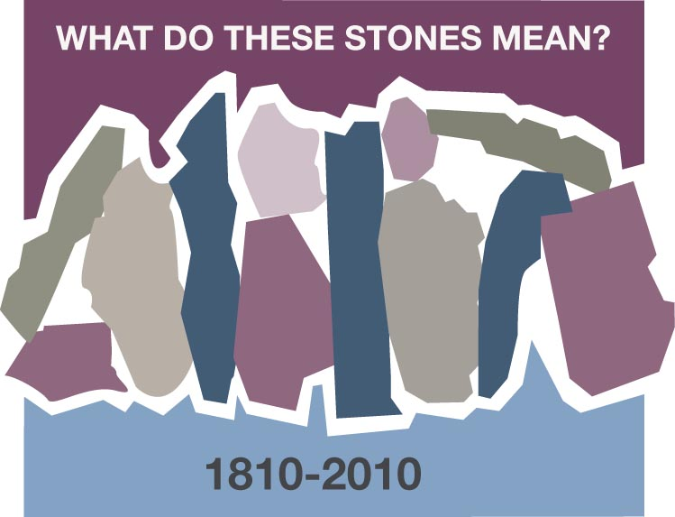
A MISSIONARY STONE
Grace Yu-Leung, Jordan, Kowloon, Hong Kong

Sometimes I love to recall the evening almost about 40 years ago, we, then the young people of Kowloon CPC, sitting on the floor of Sister Annie Skau Berntsen’s sitting room, listening to her sharing before going to visit patients of the hospital. Sister Berntsen was a Norwegian, but spent almost all her life in China and Hong Kong serving as a missionary nurse.

I was then a freshman at college, a young Christian attending the youth fellowship of Kowloon CPC. The fellowship had an outreach program monthly, we went to a hospital to lead gospel meeting and to visit patients in different wards of the hospital. Sister Berntsen would deliver a message to us before going to the wards. I could recall that evening, about twenty of us sitting on the floor of her sitting room, Sister Berntsen stood in front of the table lamp, she was so tall (over six feet), we all had to lift up our heads high to listen to her. She shared with us the miracle of Jesus feeding the five thousand. She stretched out her hands as if she was holding the loaves and fishes, and said, “And Jesus blessed them, and broke them; it multiplied and fed five thousand people. If you want to serve God, it is not how gifted you are or how good you are that counts, but the willingness to commit yourself to the Lord that counts. God can use you as a blessing to many.” My heart was touched by God, I had been praying and seeking God’s will in my life after becoming a Christian, somehow felt that I was unworthy to be called to serve God. But that evening God spoke to me, “Just commit yourself to me, including all your limitations into my hands, you will be different.” Sister Berntsen’s life testified to the faithfulness of God; she had been a blessing to many.

During my almost thirty years of ministry in the church, there were times I like to recall that evening, and when I do, my heart is peaceful and sometimes tears come out of gratitude.

Discussion Questions and Reflection Activities
Scripture: Exodus 3:11-14, 4: 11-12

Many of us have a defining moment in our lives when we knew that God was calling us to do something for His Kingdom. Some answer "Yes". Some answer, "No". Some want to bargain with God and make excuses, much like Moses did. Often we wander through a wilderness of reasons we have ready for most any request that comes our way. Even as God told Grace that He would supply the talents and words that she would need, He still speaks to us if we but open our hearts and ears and answer "Yes".

These callings may not be for a lifetime. They may be for a specific task that needs to
be done right here in your Circle or Sunday School. Grace Yu is very mindful of the missionary who was instrumental in her surrendering to a call to full time ministry. Sister Bernsten was truly a "stone," who helped Grace with her decision.

Questions:
Invite women to share of a time when they felt God calling them to some task or ministry?

When did you step outside your comfort zone to help someone, to lead a group, or
to make a talk?

Who was instrumental in leading you to hear God's call?

Prayer:
Pray that the winds of the Spirit continue to blow through your life, to encourage and challenge you in your everyday events. Ask for forgiveness, if you have not already, for the times when you have refused to listen to and carry out God's call, no matter how large or small.

