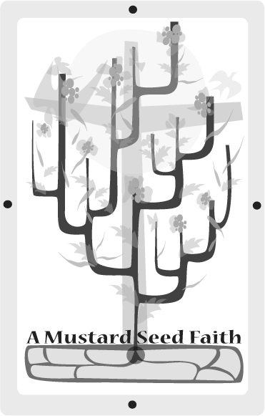
Walking to Emmaus
Luke 24:13-35

Open with the praise chorus Open My Eyes, Lord and then pray that God will touch you through His word and transform your life today.

Preparing the soil
God always uses the "unlikely" so that when mighty things are done, EVERYONE will know who really did this mighty deed.

Everyone has the used the phrase, "Couldn’t see the forest for the trees"- how really true this is of our seeing and understanding of God. We are inundated by His presence daily. God abounds all around us and His Holy Spirit speaks from within us. He speaks through His creation and through a still small voice, yet we miss Him. We sometimes go for days without experiencing the marvel of, "Wow, I’ve just been walking with Jesus!!!" We have the Word of God and we are free to worship at the church of our choice, but we sometimes we are like the legalist in the Bible and get caught up in manmade things (Roman 1:21-22), thereby failing to see God. How could Peter give such a marvelous confession of faith (Mark 8:27-29) and then turn around and desert and deny Christ? Hmmmmm! Does this sound familiar in our life? How could James and John’s mother be so wrapped up in power, influence, and position that she would ask for special privileges for her sons? (Mark 10:35-40) Do we today hear of the benefits of being a Christian without hearing of the responsibilities?

Planting
On that first Easter afternoon, two men were heading home to their village in Emmaus. They had been obedient to their faith. They had come to Jerusalem for the required feasts of the Passover and Feast of Unleavened Bread. They had brought their sacrifice. They had done all they could. They had followed the rule. Little did they know that while all this was going one, on a hill outside of town, the incarnate God was becoming the perfect, one time, all-sufficient sacrifice for the sins of man that separated them forever from a Holy God.

Read Luke 24:13-35. As we read, let us not see this as an ancient history lesson, or a fable, but as God talking to us about where we are today.

Tending
As the men walked home, they were depressed and confused because they really didn’t see Jesus for who He really was. People may call Jesus a prophet, a great man, but He says He is GOD. (See Matthew 26:63b-64a, Mark 14:61b-62a, Luke 22:70, John 14:9).

They were especially concerned that He had died. God does not live by our plans and expectations. He has a plan and a time that is perfect. The men didn’t recognize Jesus. Even though Jesus promises to never leave or forsake us, we may sometimes feel as if there are times He is not near to us.

When Jesus asked them what they where talking about, they were snippy in accusing Him of not knowing what was going on. Maybe there are times when we ask God, "Do you know what’s going on here?" WHO really is the one that is confused in this question?

Even though the men knew others had proclaimed to see evidence of a Risen Christ, they did not believe. We ALL must experience Christ individually from a willful, knowing perspective. No one can do something for us to make us believers.

Jesus then began to explain the scriptures of all the prophesies about the Messiah. Do you understand the prophesies of the Messiah? Do they strengthen your mustard seed faith? Then, Jesus started to continue on his journey. Have we missed close communion with Jesus because we didn’t invite Him to stay?

Jesus opened their eyes and they IMMEDIATELY went to tell others. Have you ever felt this joy, this release? Have you ever run to tell someone about Jesus? Do you still? What has changed?

Harvesting
Apply what you have learned from this scripture to your life today. Divide into small groups so everyone will have a chance to say something about each question.

Remember, not all our answers will be alike. Our answers will different because of our education, life experiences, and where we may be in our walk with Christ. We can learn from EVERY answer, though.

1. The statement, "To those to whom much has been given, much is required"---how does that apply to American Christians?
2. Have you walked in spiritual darkness? Talk about those times, if you are able. Do you still see Him as you did when you were a child?
3. Note the importance God puts on ALL people. He appeared to two men at this busy season of His earthy visit. How does this fact make you feel?
4. Name some things in American and/or world affairs that let you know God is near.
5. How does WHO we walk beside affect our walk with God?
6. Could we go to church and get so involved that we don’t see God? Explain.
7. What are some titles the world gives Jesus today?
8. How does this story show that God pursues us, we don’t pursue Him?
9. How well do Christians understand the Old Testament so we can explain about the Messiah to others?
10. When Second Coming of Christ happens, do you think some people will miss him? Explain. What is our role in making sure that everyone knows Jesus?

Celebrating the bounty
Look around the room. Look out a window. Where do you see the presence of God? How does that lift your spirits?

Pray that God will build a desire for a greater awareness of Him in your life. Pray for -
1. Eyes to see Jesus.
2. Your church to be faithful to His call and to present Him to others who cannot see Him.
3. Your continued desire to RUN and tell family and friends about Jesus.
4. Yourself and your ability to tell this story.
5. America -- That our country will repent and return to God, so we can be that light on the hill for the world.

Close with a song
We’ve A Story To Tell To The Nations
Where Ever You Lead I’ll Go
Surely The Presence Of The Lord Is In This Place.
Just a Closer Walk With thee

Jeanne McCutchan is a retired schoolteacher and counselor. Since "retired' she can now quicken her race for God. Jeanne works in her church, an international ecumenical Christian community called Tres Dias. She is also active in ministry in local nursing and retirement homes. She also volunteers in the community by tutoring in a school two days a week and by ushering at performing arts events and helping with the local Tourist Information Bureau.

