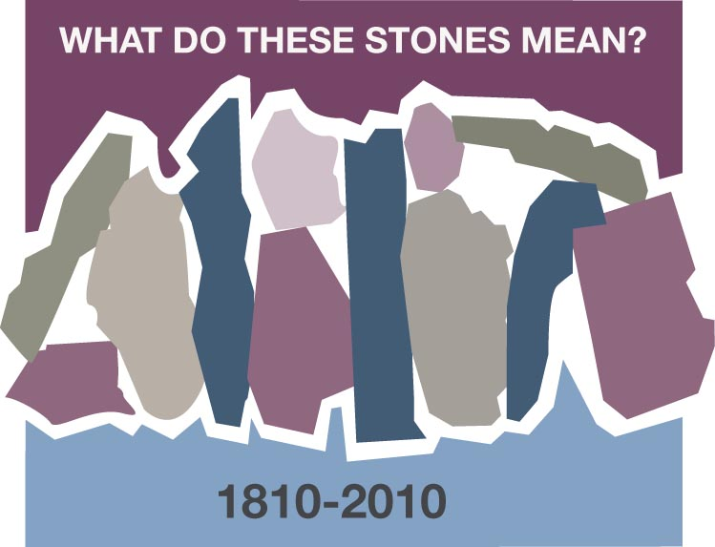
JERUSALEM CUMBERLAND PRESBYTERIAN CHURCH
Cornelia Swain, Memphis, TN

Jerusalem Cumberland Presbyterian Church (yes, it really was and is Jerusalem Church) is the “stone” in my life. (It has always been fun to tell people that I am from Jerusalem!) It was a very small, rural church, but it was “my” place from the time I was born until I finished college except for a period during World War II when it was closed. Numbers were very small and people had little money or gas stamps to go where they needed to go including church.

After a time the church was revitalized and we began having services and Sunday school on Sunday afternoon because that was when we could get a minister to preach. But it continued to grow and develop so that we began having morning services twice a month, but Sunday school every Sunday. It was Sunday school that was the mainstay of our church as everyone came to Sunday school and stayed for worship when we had a minister.

Originally we had a one-room church building with classes meeting in the corners of the church. That was sometimes difficult as my father taught the adult class, and he did not have a soft voice. But we made the best of it and learned our Bible stories, memorized Bible verses, and had some activities and “picture cards” to go along with the story.

Our teachers were not what we would call “trained” by today’s standards, but they were wonderful people who were very committed to teaching all the children and young people to know the Bible, believe in Christ, and give our lives to Christ as Savior.

As I grew older I began teaching the high school class, which was really my own age group, but it was quite a learning experience even so. By then we had added a couple of Sunday school rooms at the back of the church so we had our own room behind folding doors, for which we were very grateful.

It was during the Sunday school assembly that I began playing the piano for people to sing. The leader and I would pick out the hymns, and I would practice at home all week, so I could play them the next Sunday. And then at some point I graduated to being the church pianist.

It was in this church that I made my profession of faith in Christ, joined the church and dedicated my life to Christian service. It was through very dedicated leaders and Christian parents that I continued to grow in the faith and began searching out my calling. I always knew there was a special place for me. Though it took a while to find that place, I never wavered in the fact that I was “called” just as certainly as any clergy person feels a call to preach.

This place is my “stone” and this stone has meant that I grew and developed as a Christian in a very small, rural church that provided for me the foundation of my faith and my call to Christian service. So I join with many of you in thanking God for the small churches which were/are very dedicated in their ministry and willing to go the second mile to provide Christian training for all their children and youth.

Discussion Questions and Reflection Activities
Scripture: Colossians 2:7; 3:16

Cornelia shares with us precious memories of a place dear to her heart. A small country church nurtured and shaped her into the leader that she became, serving on the staff of our denominational Boards of Christian Education and Missions for many years. At the same time her home church grew into a thriving congregation.

Many of us may have come from home congregations where we still serve. We give thanks for the "stones" that guided our way into maturity, allowed us to develop our talents, and challenged us to become "stones" in our own right. Or we may have moved into new and modern environments where we can shine forth as lights in the darkness as well.

Questions:

To what church do you give credit for helping to make you the person you are today?

Who were the "stones" that inspired and shaped you?

How is your Circle, Sunday school class, and church governance specifically developing opportunities for the youth and new Christians in your congregation and area of influence? What more can be done to inspire our youth and new members?

Prayer:
Lord, we give thinks for those who came before us and provided for our spiritual guidance as we grew in the faith. We pray for your continuing guidance in our roles as shepherds and helping stones to our youth and the "seekers” in this church and community. In the name of the Good Shepherd we pray. Amen

