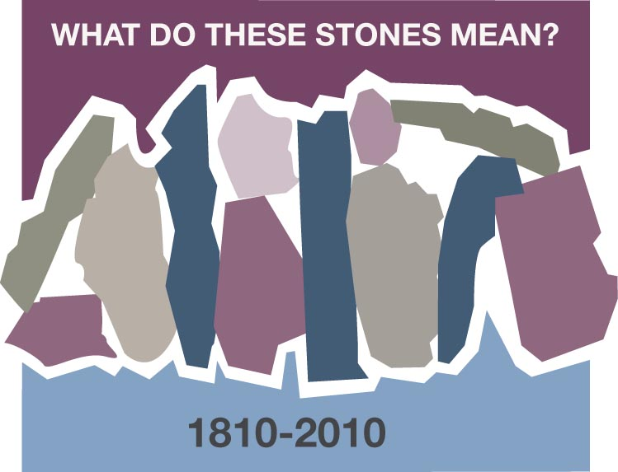
STONES IN THE POCKETS
Carla Sims, Harvest, Alabama

When my son was little, the laundry was never boring - routine, but certainly not mundane. I quickly learned that the contents of a small boy’s pockets and any household appliance are not compatible. Pocket excavation was vital, seeing as I had previously washed and subsequently dried bubble gum, baloney, rocks, “Mighty Max” figures and, yes, a couple of real minnows.

The constant I found during each pocket scavenger hunt was rocks. There was always a stone of some sort in every imaginable pocket in my son’s clothing. Curiosity got the best of me so I began asking him about the rocks. It was like playing show and tell in reverse. Sure enough, he could eagerly tell me about each one; where he found it and why he kept it. The more I learned about the stones that fascinated him, the more I learned about my little boy. For instance, one he discovered while running through the woods with his dog. Another stone was uncovered after he jumped out of a swing at the park. A few he dug out of the mud when he was supposed to be listening in an outside Bible school, and several were cool souvenirs from trips. One of my favorites he carved into a cross necklace for me.

As my son has grown older, some stones are now too large or heavy for his pockets. But, whether they are collected in the trunk of his car, baggies, at a gem and mineral show or even in the pockets of a pair of tall blue jeans, each stone has a wonderful story and a reason for keeping it. Our garden, flowerbeds, kitchen window sill and even my jewelry box display meaningful testaments to his life’s journey. They tell where he has been and even where he’s going. He will begin gemology school in the fall.

So, how can anyone visualize my life’s journey with God? Simply check out my heart’s pockets; the people, places, things, events and circumstances I choose to keep as vital reminders of where I’ve been and, perhaps, where I am going. Each stone has a story and I pray is an encouragement to others, testifies to the faith I deeply cherish, causes someone to think or even just have a good belly laugh. Most of all, I want my rock pile to stir the curiosity in everyone enough so that they begin to pilfer through their own stone collection. I promise, the discovery is never boring.

Discussion Questions and Reflection Activities
Scripture: Matthew 13:44

Many of us will be reminded of days gone by when we retrieved the treasures of our sons from pockets, washers, and other places. Others of us are still finding them. How precious these memories are. If the child has not put them in their secret place then perhaps we have them stashed away so they may claim them someday.

These treasures may be as simple as rocks from the driveway. They may not be worth much, only to a child, but some might indeed be very valuable. Our own adventures in Christianity could be rich in gems and treasures as well. Take time to search an old study Bible or Bible study workbook. Reread your musings and written prayers.

Questions:
Do these treasures still have meaning to you? Are you surprised at what you find?
Have you carried out the promises hidden away or are you still waiting for a more opportune time in which you could work on them?

What memories could you share of finding "hidden "treasures”? These could be stories of your children or from your personal life and studies.

Prayer:
Grant us, Father, new eyes to see the treasures contained with your word, in our fellowship with each other, and in your creation. We thank you Father for this bounty, for which you have given us. Forgive us when we wear blinders or become too self-absorbed to notice the wonders you have for us. In Jesus name we pray, Amen

