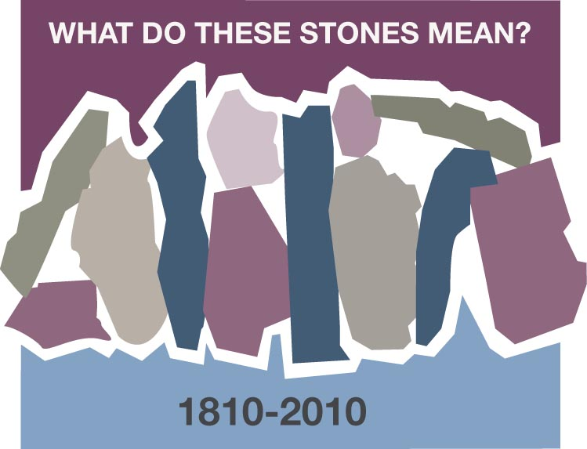
THE LAND ROVER
Beth & Boyce Wallace, Cali, Colombia

The early Land Rovers were sturdy, strong and uncomfortable vehicles that needed log truck drivers to steer them, but they were ideal for the rough Colombian terrain. We bought ours from Glenda who was returning to California shortly after her husband died. The Land Rover had a bullet hole in the top, which caused every rider to ask, “What happened?”

Glenda had met and married Obdulio Barrios, Jr. while he was studying agriculture at Stanford University and they moved to Armenia, his home town, to be in charge of his father´s coffee farms. They had just settled in when on a Sunday afternoon drive with their two small children they were stopped by armed men who kidnapped Obdulio and took him in his Land Rover. No one knows what happened in the jeep but he was shot and one bullet went through the roof. He was left abandoned to die in the jeep. He was found barely alive and brought to Cali where he died in the hospital.

The bullet hole in the Land Rover was punctured at the beginning of the kidnapping phase of the 50 years of violence in Colombia. Thousands of Colombians and foreigners would be kidnapped in the next twenty years. Some are still being held today.

Obdulio was part of the Barrios-Correal family that had moved into Quindio, where the rich soil has made it the coffee growing sector of Colombia. They were also among the first to hear the Gospel preached and became strong Christians. They would become founders of the Cumberland Presbyterian Church in Quindio, now a Colombian state. These pioneers of the Gospel knew the horrors and persecutions of the earlier political-religious phase of the Violence and now experienced it first hand with Obdulio´s murder.

Earlier opposition to the Gospel and persecution had not extinguished the Evangelical churches in Colombia. Neither would the kidnappings destroy the faith of the family. What does this bullet hole in the top of our old Land Rover mean? It reminds us of a living faith in the midst of violence. The Bible is stronger than the bullet!

Discussion Questions and Reflection Activities
Scripture: 1 Corinthians 15: 55-58

Beth and Boyce Wallace have served in Colombia, SA since the mid 1960's. They persevered and served there in spite of the long period of "The Violence" with it's kidnappings and murders, even choosing to continue living in this their adopted homeland after their retirement still today.

In this lesson the "Stone" to which they refer might have been considered by many to be
a stumbling block rather than a building block. Instead, the stories they tell always reflect
a message of hope and encouragement for all who would hear. Many times our churches in Colombia are the only stones of help in a barrio or neighborhood, providing shelter and inspiration from the Gospel preached for those who believe. What an inspiration they provide to us!

Questions:
In our country are we allowing fear of terrorists and unknown dangers affect our witness?

How does this testimony inspire you to not "live in a spirit of fear"?

Name some “stones” of belief your local Women’s Ministry group provides for a few or for any who come seeking solace, courage and inspiration in the midst of a fearful world?

Prayer:
Heavenly Father, too often we allow fear to overcome us and keep us from carrying out the mission you would have us do. Forgive us when we allow a spirit of fear to block out the light of your love and keep us from doing your will. Thank you, Father for the witness of our Colombian sisters and brothers in Christ. We do, so earnestly, pray for your continuing guidance and inspiration in this fearful world in which we live. In Jesus name we pray, Amen

