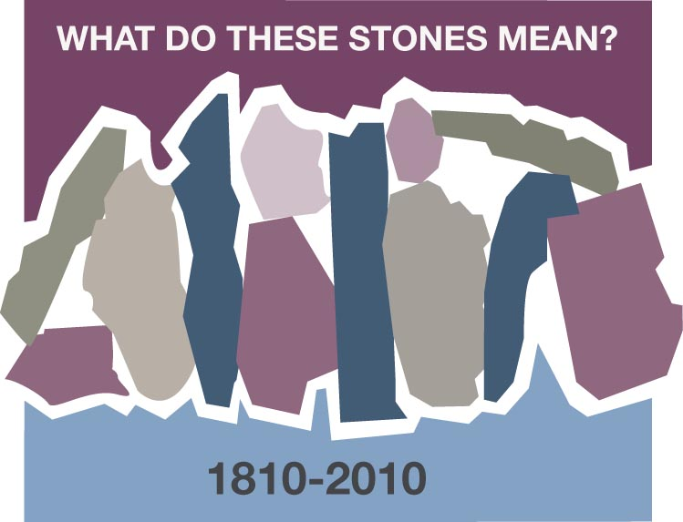
A RAINBOW
Beverly Stott, Dresden, Tennessee

What do these stones mean? The answers are as many and varied as the individuals asked. Ultimately they bind us together as Cumberland Presbyterians. Walk with me as I share one of the “stones” in my life.

The USS President Cleveland moved away from the pier into the San Francisco Bay. The journey had begun for us and we watched in awe from the deck of the ship as family and friends grew smaller in size and the colorful streamers connecting us began breaking. Soon we were under the beautiful Golden Gate Bridge and into the wide expanse of the Pacific Ocean. Some two weeks would pass before we arrived in the port of Yokohama, Japan. Thus began the first missionary journey for the Stott family – Buddy, Beverly, Bruce, Kell and Paul.

There was much excitement but also some anxiety and apprehension. Were we truly prepared? We’d done lots of paper work and been thoroughly questioned by the members of the Board of Missions; we’d undergone a psychiatric examination; had three months of language study under a private teacher; packed and shipped our belongings to the west coast; commissioned at General Assembly in Chattanooga, TN in June 1964; said goodbye to family and friends; and drove to San Francisco.

There was no doubt in our minds that God had directed our paths to this point and would continue to do so. He would be with us each step of the way.

We were encouraged and strengthened by the faith of other missionaries on the ship – some had served in Japan and other countries for many years. We enjoyed Bible studies and prayer meetings with them.

Buddy and I frequently arose early to go up on the deck of the ship just to have some quiet moments. With three very energetic young sons, quiet times were special. It had been raining.
Suddenly we could see a double rainbow across the expanse of the sky and the ocean. The colors were so brilliant. We stood in awe and wonderment of this sign of God’s promise to Noah thousands of years ago.

To us it was of special significance. We were embarking on a missionary journey not knowing what was ahead. God was assuring us of His presence in all that we would encounter and undertake. The wonder of this moment would sustain us for some twenty-six years in Japan and beyond.

I am truly blessed and grateful to be a small part of this wonderful family called Cumberland Presbyterian. The “stone or stones” in each of our lives is a great and colorful story which we need to share and celebrate.

Discussion Questions and Reflection Activities
Scripture: Matthew 28: 16-20

In keeping with the theme "What do these stones mean", Beverly Stott tells of a time of immense
anticipation as the Stott family left the comfort of their home country to cross over into a new land and a culture to which they were not accustomed. Even thought they experienced anxiety and apprehension, they knew that God was with them every step of the way. Knowing that God does not call every Christian to travel to strange and distant lands, we need to be always be listening for God's call in the places we find ourselves each day.

Questions:
Describe a time in your life when you knew that God was calling you to a new place, a new job, or a new life situation. If you made this decision, how has it affected the rest of your life? If you did not accept the new challenge, how do you think this choice has affected your life?

How are you as a Women's Ministry group attempting to carry out the Great Commission given
by our Lord Jesus Christ in the places where you live and witness? What stones are you placing in your community that will last through the generations?

Prayer:
Gracious Father, we thank you that you have called your followers throughout the ages to go to new places to deliver your message. We also give thanks for those who came among us to teach and guide us in your way. Forgive us, Father, when we have failed to listen or act on your call. May we always be open to your guidance and be assured that you would be will be with us in every step that we take to do your will. In the name of our Blessed Savior we pray. Amen

