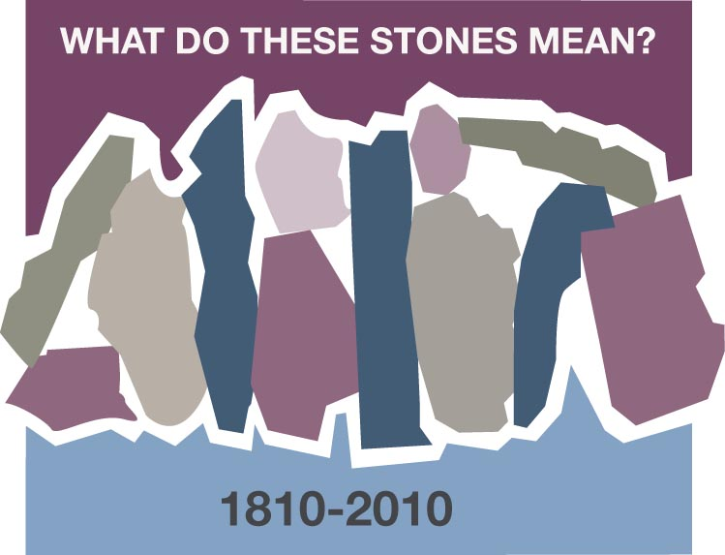
A CHOCTAW STONE
Betty Jacob – Broken Bow, OK

We are Choctaw American Indians, the first mission of the infant denomination called Cumberland Presbyterian, and we have unique stones of remembrance in our history. We will identify, to those who come after us, those stones that have been God’s blessings to us in the past for they are a witness of His stance for us in this age, and in the age to come.

It is important to recall those great and wondrous things that happened to us as we continue our journey to Beulah Land. That was so with the tribes of Israel. God’s plan was that they use remembrance stones! The command concerning this was that the stones be taken out of the river where the miracle took place – one stone for each tribe – and tell the story, “when your children ask what these stones mean to you, you will tell them…”

The tribes of Israel were told what to say when the question came, “What do these stones mean?” Their leading from God becomes our leading in this age.

Choctaw American Indians speak from our own stance. Cumberland Presbyterian Choctaw Indians have a witness unique to us, and yet exactly like every other group’s story. Our story points to a time and place and blessings that we share with those who rejoice with us, for they have seen the same God in a different way, in a different river.

“Why did this Samuel King and William Moore come to the Akla Ahe Apat Tribe?”

“Why did these Cumberland Presbyterians feel a need to build a school for our people there on the Itombiikbi River?”

“Why did Israel Folsom’s mother long for the presence of the Cumberland Presbyterian Church, causing Israel to feel an obligation to re-establish its presence among our people?”

“Mother! What do these stones mean?”

In addition to the vision and work of the mother of Israel Folsom, there are countless Choctaw women who have added to the Cumberland Presbyterian story. These women are stepping stones for our children who will follow our footsteps. The Choctaw Cumberland Presbyterian women are “stones” for not only Choctaw children, but other children of other times and places who walk in the land where they walked. These women will be an encouragement; stones of remembrance. Their lives will be a witness that God has been close to us, is close to us now, and will be always.

The February 4, 1810 stone will be added to the 1818 Samuel King and William Moore stone. We will find other stones that add to our story. Then we shall surely glimpse the glory of the Lord.

Discussion Questions and Reflections Activities
Scripture; Joshua 4:1-9

As Betty Jacob points out, the Choctaw Indian Nation was one of the very first mission outreaches of the early Cumberland Presbyterians. She uses the image of stones being taken out of a specific river to celebrate a specific happening in Hebrew history. Betty points out that we have all come from different rivers. She uses the tradition of the Choctaws children questioning their elders and mothers about their early beginnings. In this manner, unique traditions will not be lost from generation to generation.

Let each of our Women’s Ministry groups be ever mindful from wince our stones come.

This would be a good point in our studies for each women’s group to create some kind of memorial containing the "stones" that have helped make us who we are. If you already have a written history make sure that you know where it is and review it. Share it with the rest of the congregation.

Questions :
Has your own family had a tradition of asking the elder members about their past? Share with the group your traditions.

Who is the Historian of the family? of the local church? Who will take their place when they are gone?

How do we respect our history (stones) without worshiping them as the pagans did?

What does the symbolism of the "different rivers" mean to you?

If the rivers merge, do they have to lose their individuality? Talk about what happens when rivers merge – the challenges and the blessings.

As the number of cross-cultural fellowships are added to the CP Church, how will we respect the "different rivers" and yet join together as the Body of Christ?

Prayer:
Take a moment to be thankful for the stones and rivers that God has called together to make the Cumberland Presbyterian Church. Ask for the spirit and courage that guided these in the past to continue to guide our future. Ask for forgiveness for our idol worship

