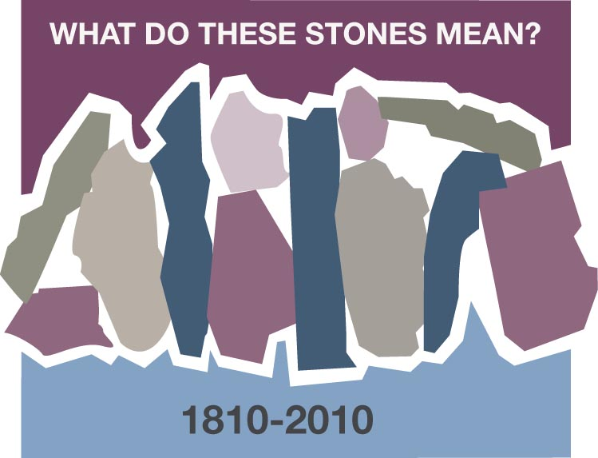
A STONE OF ENCOURAGEMENT
Beverly St. John, Brentwood, TN

In the 1950’s I was a young mother of two little girls, a homemaker, and free-lance artist when I received a letter from Miss Virginia Malcom with the Board of Christian Education. Her request read as follows: “We would like to invite you to write an article for a monthly publication for young parents titled “My Baby and His Church.” She proceeded to tell me how long it should be, doubled-spaced, etc.

I responded saying, “Thank you, Miss Malcom, but I am a commercial artist – not a writer.” She wrote back: “All we know is that you are a devoted mother and active in the Brookhaven Cumberland Presbyterian Church. We thought that you would have some interesting experiences to share with other young parents that might be a source of inspiration for them. We will pay you $10.00 for each article. Please try to write three.”

I thought for a while then borrowed a typewriter, and jotted down the story of the birth of my first child. When she was a few hours old, the nurse came bringing her to me, laid her to my breast and said, “Feed her – she’s hungry.” I began to think of the many ways that children are always hungry - not only for food, but love, encouragement, and discipline.

With much anxiety I mailed the article to Miss Malcom. She responded with “good job! So I wrote another, and another. There! I had done three, just as she had asked. She wrote again: “We like your work - would you please write three more?” Several months later they changed the title of the leaflet to “The Twigs” and asked if I would make some drawings for the covers – one for each of the four seasons. I was excited! I got out my drawing board and made four drawings. They too were accepted. The short of it is that I continued writing one story a month for six years (even during a move to New Jersey and back!). By that time my “little girls’ were almost teenagers and the time had come for me to let someone else tell their stories.

A few years later the Board of Christian Education chose 23 of the articles and published a book titled “As the Twig Is Bent.” I was also asked to design the book jacket and do a few illustrations. I was an author! Never did I dream…. I even discovered that I enjoyed writing – because of “Miss Virginia” – a wonderful stone in my young life.

Her encouragement taught me that we are called to encourage fellow Christians to discover their talents, and use them for the Kingdom. St. Paul, on several occasions, admonished his followers to use their gifts – whatever they might be, as a means of “growing a church” – the Body of Christ, a church that is founded on living STONES – made up of loving people who are willing to “give it a try!”

I like the story of Michelangelo who was rolling a big slab of marble down the street one day. People along the way yelled: “Mike, what are you going to do with that old rock?” To which he responded: “There’s an angel in there that is dying to get out.” There are “angels” in all of us dying to get out – they just need a little nudging!

Discussion Questions and Reflection Activities
Scripture: Isaiah 6: 8

Many of us know Beverly St. John as a dynamic leader of both the former Cumberland Presbyterian's Women's work and the first female moderator of our General Assembly (1988). Even one of such stellar reputation must start somewhere to take a leadership role. One of Beverly's first stone was a writing assignment. She used this stone not as a stumbling stone, but as a building block. Just as Beverly found the church to be filled with "Living Stones", we as Women's Ministry members are called to build on the foundation that is already here and to be "Living Stones" for others around us.

Questions:
Who was the first "Living Stone" to come into your life and give you a challenge, which has served to help you become a vital part of the Body? (It may have been in some long ago church or it may be right here where you live and worship now.)

When was the last time that you accepted a challenge to do something that you really considered out of your comfort zone or abilities, but you accepted anyway and was blessed by it, and became a blessing to others?

Just as Michelangelo could see an angel in a rough stone, we too, can see potential in others. Who is the Spirit leading you to encourage? Is it a youth, a family member, or even the person sitting next to you? What are some specific ways that you can bless and encourage them?

Prayer:
Close in prayer, asking God and the Holy Spirit to guide you in your decisions when asked to perform a task, as well as guide you as a "Living Stone" to someone who needs your encouragement to use the gifts God has given them.

