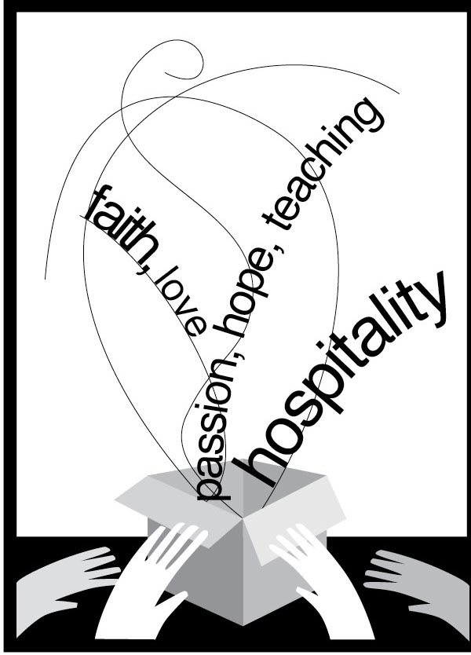
Gifted to Serve!

This year’s Women’s Ministry theme will capture us all as we think about and reflect upon the many gifts with which God has blessed us. We will learn that we have been gifted to serve others! The Bible Study this year is in the format of a one-page monologue with reflection questions and activities. The Rev. Tiffany Hall McClung, Chaplain for Memphis Theological Seminary, writes the monologues for this resource. She graduated from MTS in December 1999 and was ordained by Nashville Presbytery of the Cumberland Presbyterian Church in February 2000. She has served as youth minister, associate pastor, and pastor to congregations in Tennessee and Alabama. She holds the distinction of being the final president of the Cumberland Presbyterian General Assembly Council. She is married to the Rev. Dr. Andy McClung, also an ordained C.P. minister and they have two children, Ian and Maggie. They live in Midtown Memphis, Tennessee. You can contact her at tmcclung@memphisseminary.edu. Mrs. Michelle Rackley writes the reflection activities. Michelle is a graduate of Emory & Henry College with a degree in Early Childhood Education and English. She went on to attend Union Theological Seminary and the Presbyterian School of Christian Education receiving her Master's of Divinity and her Master's of Arts in Christian Education. She is married to the Reverend Mark Rackley, who pastors the Bartow Cumberland Presbyterian Church in Rydal, Georgia. They are the proud parents of Sarah Catherine, Paul William, and Anna Rene. You may contact Michelle at mandmrackley@gmail.com.

In preparing for these studies, you will want to read all the text beforehand (and maybe even research more of the characters in order to give a fuller, richer presentation). It will be best if you can do these monologues in first person, even dressed as the woman being portrayed. The most effective way to facilitate these studies will be for one woman to give the presentation and another lead the discussion afterwards.

Included with these studies is a simple calendar that you might find helpful in your planning for the year. Please feel free to adjust and modify to fit our group’s unique needs. There is also an order form at the back, which you can use to order additional resources related to the yearly theme and Women’s Ministry.

Blessings as you hear once again, the stories of some amazing women of God who used their gifts to serve others, and who will challenge us to do the same.

